**Title**

Tools for packaging static webpages for the development of Multiscale Geo-structural Information Systems (MGS) using Python and open-source software

**Running title**

Open-source tools for crafting Multiscale GIS

**Authors**

Gaetano Ortolano1, Gianfranco Di Pietro2(\*), Alberto D’Agostino1, Roberto Visalli1, Eugenio Fazio1, Rosaria Ester Musumeci2, Rosolino Cirrincione1

**Affiliations**

1 Department of Biological Geological and Environmental Sciences, University of Catania, Corso Italia, 57 - 95129 - Catania, ITALY

2 Department of Civil Engineering and Architecture, University of Catania, Cittadella universitaria Via Santa Sofia, 64 - 95123 - Catania, ITALY

**Conflict of Interest**

The authors declare that they have no conflicts of interest.

**Acknowledgments**

**Tools for packaging static webpages for the development of Multiscale Geo-structural Information Systems (MGS) using Python and open-source software**

**Running title**

Open-source tools for crafting Multiscale GIS

**Authors**

Gaetano Ortolano1, Gianfranco Di Pietro2(\*), Alberto D’Agostino1, Roberto Visalli1, Eugenio Fazio1, Rosaria Ester Musumeci2, Rosolino Cirrincione1

***Abstract***

Geologists produce and analyze various multiscale datasets to reconstruct the kinematics of Earth’s deformational processes. The study of tectonic-related rocks (e.g., mylonites) allows for the extraction of geo-structural parameters, which are particularly suitable in this scenario. The use of Multiscale Geo-Structural Information Systems (MGS) is effective for a comprehensive representation of complex geodynamic processes, which can only be achieved truth the simultaneous comparison of data from different scales. We propose a methodology for quick packaging of MGS, especially suitable for mylonites, using ad-hoc Python scripts and open-source software. This approach improves connecting information across various scales of observation: from petrographic micro analysis to 3D UAV surveys. We have developed an MGS for studying the mylonites occurring at Palmi Shear Zone (South Italy), one of the most important sites for understanding geodynamics processes of Mediterranean area.

MGS have potential applications in territorial planning, resource management, data interoperability and risk analysis.

***Keywords (max 6):***

*3D UAV, Earth geodynamic visualization, Multiscalar, Mylonitic rocks, Palmi Shear Zone, Thin sections, webGIS.*

# Introduction

The current technological landscape is dominated by digital transformation trends such as Cloud Computing, the Internet of Things, and Cyber-Physical Systems. These technologies generate, store, and process massive amounts of data. The volume and complexity of data generated by these technologies make the aspects of effective communication of data and results of scientific studies challenging. Data visualization bridges this gap by transforming raw data into visual representations that are easier to understand and interpret. This interdisciplinary field leverages visual tools and techniques to effectively communicate information hidden within complex datasets (Kirk, 2012; Walny *et al.*, 2020).

In petro-structural geology studies (i.e., studies based on the extrapolation of quantitative parameters from deformed rocks by tectonic processes), researchers produce a wide range of multiscale data (e.g., Ortolano *et al.*, 2020; Fazio *et al.*, 2024a) that, if represented through suitable web-based visualizations, can give a more effective and interactive representation of the reality.

These include geographic location and spatial orientation of geological and structural data (i.e., foliation, lineation, joints – Passchier & Trouw, 2005) and quantitative petrographic data collected from image analysis of digitized rock thin sections (e.g., Ortolano *et al.*, 2014, 2018, 2021; Visalli *et al.*, 2021).

These data can be appropriately characterized as multiscalar (Melsom, 2020), since the scales at which they are generated and produced vary significantly, spanning from the kilometer scale for geographic-related data to the micrometer scale for rock thin-sections data. Although seemingly unrelated, these data often require concurrent analysis to uncover specific geological insights. This, in turn, underscores the need for a strategy to efficiently represent multiple and multiscale geological data within the same Web environment.

The variety of geological data translates into different data types, including geographic raster data, non-geographic raster data, and vector data. Raster data consists of arrays indexed by specific coordinates within a coordinate reference system (CRS) for georeferencing (González Canché, 2023). Geographical raster data requires precise location referencing, non-geographic raster data, such as optical microscope scans of rock thin sections, faces limitations in georeferencing, making it theoretically and practically infeasible to apply typical geo-cartographic paradigms. This necessitates alternative methods for linking non-geographically referenced data, often via web-based maps or 3D navigators using non-geographic systems. These considerations are equally relevant to vector data, where geometric primitives, defined by vertex coordinates and their associated structures, may be referenced within non-geographic, local Cartesian coordinate systems.

In data visualization, especially for web-based geospatial applications, design must prioritize effective communication with the target audience, ensuring at the same time seamless data accessibility. This balance is particularly critical during the post-processing and representation phases, where user-friendly access and clear communication are essential features (Krygier & Wood, 2016).

When designing tools that convert geological data into visualizations, it is essential to ensure that the resulting data viewers effectively convey information to the end users. Such tools should provide flexible and controllable operators in order to fine-tune the data viewers' output for optimal communication. This is crucial for empowering geology researchers who generate data, giving them the autonomy to create web-based visualizations directly without relying on intermediaries (Foerster *et al.*, 2012).

It might be difficult to display data and graphics online while referencing several scales and representations. Thematic maps linked to analysis results, 3D, VR, or augmented reality models in combination with spatial statistics are only the simplest use cases of a multiscale approach. In all these cases, it is necessary to contend with different paradigms of graphical representation and the use of different and well-differentiated information technologies for the visualization and interrogation of data by users on the World Wide Web. 3D or Virtual Reality applications, Web-GIS, and more complex query systems must coexist in unique web environments. Data scientists who make multiscale datasets often must turn to web providers for visualization on the web of the results of their analyses (Romero-Organvidez *et al.*, 2024).

This research proposes a methodology facilitating the autonomous publication of multiscale data to a static website, obviating the necessity for reliance on external service providers (Mete & Yomralioglu, 2021). By capitalizing on the capabilities afforded by open-source libraries for web development, the potential of crafting tools that facilitate the publication of multiscalar data on the Web is explored, encompassing both geographic related (i.e. macroscale structural data) and non-geographic related (i.e. microscale structural data) information. These tools are not meant to automate the full process of building an entire web environment or web-based application from scratch. They rather provide easy and ready-to-use instruments to quickly convert typical geological and GIS data types, such as rasters, vectors and 3D models, into a web-friendly format, using a multiscalar approach.

By the implementation of a “static-website” generator, a fast and efficient process for a Multiscale Geo-Structural (MGS) Web-GIS development has been formulated. This ensures the resultant website is rapid and facilitates the seamless publication and dissemination of geodata visualizations. Static websites are a simple and efficient way to present content online; unlike dynamic websites, which rely on server-side processing, static websites are pre-built and deliver content directly to the user's browser. This makes them a good choice for businesses and individuals who want a fast and easy way to get their information online (e.g., Kumari & Kumari, 2023). A schema of the “static webpage” approach in the Web-GIS environment is illustrated in Figure 1.

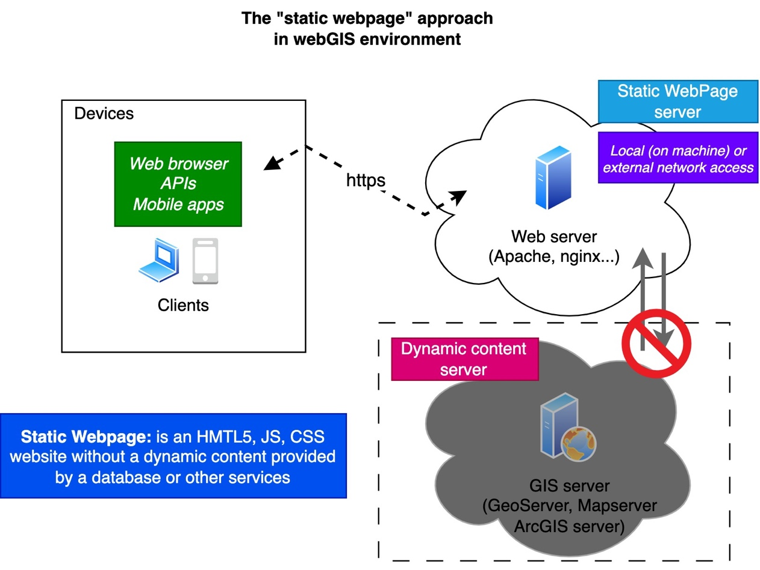

Figure - Static webpage approach in webGIS environment

In order to better highlight the potentiality of the proposed work, we focused our attention on the study of mylonitic rocks. These tectonic related rocks, indeed, are of particular interest due to their capacity to preserve fabric-related records linked to specific conditions of temperature, pressure and strain rate (e.g., Passchier & Trouw, 2005; Xypolias *et al.*, 2010). More in particular, these rocks may develop structural- features at different scales of observation, which are routinely used to trace the kinematics of the mutually interacting geologic bodies subjected to the Earth's geodynamics (e.g., Cirrincione *et al.*, 2012; Ortolano *et al.*, 2013; 2020; 2022; Fazio *et al.*, 2018a; 2018b; 2024a; 2024b).

Since 1984, Wise and other geologists have categorized mylonitic rocks as an intermediate zone, positioned between cataclasites (i.e., tectonic-related rock types developed at low temperature and very high strain-rate) and the ‘ordinary’ metamorphic rocks (i.e., tectonic-related rock types developed at high temperature and at intermediate to very low strain-rate). This classification is based on their strain vs recovery rates, which are moderate compared to other tectonites (i.e., rock types characterized by penetratively and pervasively tectonic-related structural features). As such, mylonitic rocks investigations allows for the unravelling of Earth's geodynamics, representing, where well preserved, a "moving picture of the Earth."

Specifically, we used the mylonitic rocks derived from the activity of the Palmi Shear Zone (Ortolano *et al.*, 2020; Fazio *et al.*, 2024a) as an example for testing the workflow of the proposed MGS Web-GIS project.

# Methodology

The challenges faced during the implementation of a “static-website” generator primarily revolved around the need to represent multitype and multiscale geological data simultaneously within the same web view, providing at the same time non-expert users with a friendly way of generating HTML codes. The complexity of handling multi-type and multi-scale geological data is determined by different types of data, structures, and queries.

Raster data-typecontains information referring to a single cell (pixel) defined by specific coordinates and value. It consists of an array that assigns one (or more) values following a precise and continuous 2D type indexing. Defining the location of the array at a precise point in real space is an integral part of the data itself. Indeed, within the geographical domain, it is standard practice to georeference raster data by utilizing parameters contained within a coordinate reference system (CRS) definition file or metadata associated with the specific datum (e.g., GeoTIFF). For geographical raster data, a precise and unique location on a reference datum must be referenced for each cell within the dataset. Several widely used tools also allow coordinate conversion between datums, by considering validity ranges and unavoidable deformations (Snyder, 1997). For non-geographic raster data (e.g., optical microscope scans of rocks thin sections), although georeferencing the image into an oriented 3D datum by meticulously acquiring topographic information during sample extraction would be theoretically feasible, the operational complexities and the limited utility of high-accuracy information for geological purposes make such process impractical. It would be possible to assign a precise geographic location like, for example, the exact placement and orientation at the original scale of the rock sample from which a thin section is extracted. However, apart from being usually unreasonable, this is not practically possible due to the extreme scale difference between minerals displayed in a thin section (usually 10-6 meters scale) and rock outcrops (up to 103 metric scale). Finally, attempting to define microscale raster data using the same paradigms employed for cartographic rasters or sensor/satellite image datasets lacks both theoretical and practical justification. Consequently, the need arises to move beyond the standard paradigm that uses two-way correspondences between internal coordinates in a raster and coordinates in a geo-cartographic reference system.

This paradigm assumes a bidirectional correspondence between a pixel in the raster with a physically existing point in space; for the reasons stated above, it may not always be applicable or have meaningful results. It must therefore be recognized that there is a threshold of detail beyond which, for the purpose of communicative effectiveness, the notion of a digital twin of a georeferenced object in space is no longer applicable. Consequently, links between information and non-geographically referenced data need to be established. This goal must also be achieved by continuing to use web representations akin to maps or 3D navigators while employing non-geographic reference systems.

The above considerations can also be deemed pertinent in the context of vector-type data. Geometric primitives, defined by the coordinates of vertices and their inherent structures, can be referenced to non-geographic, local Cartesian coordinate systems. As a consequence, in a multi-scalar model the approach of having a single reference system for all data must be bypassed. While the convenience of a unified representation system is sacrificed, there is a distinct communicative advantage in leveraging the diverse array of geometric data representation systems available today. These include 3D models, traditional geographic information systems (GIS), and 2D maps tailored for microscopic or small-scale features. The web development landscape offers numerous open-source libraries that empower data scientists to readily create web viewers with minimal resources and technical expertise.

Starting with geographic datasets from geological surveys, 3D models from topographic surveys, and image-sensing analyses conducted on thin sections, it is possible to generate easy-to-publish data visualization and query interfaces with a few steps and basic web development skills. Using some of the most popular JavaScript libraries that are freely available under an open-source license, it is possible to configure a complete framework that contains it.

* Bootstrap and JQuery libraries for graphics and general layout of the website.
* OpenLayers and LeafLet libraries for the geographic data and Web-GIS
* THREE.Js library for the representation of 3D models

Through some purpose-built algorithms developed in Python, which can also be embedded in QGIS, ArcGIS and other software, it is possible to generate pre-configured HTML files for quick publication on a blog or website. To take advantage of the communication capabilities offered by Web tools, it is necessary to expose the results in Web sites by using the capability offered by Web-GIS and front-end systems developed in HTML5. Numerous possibilities exist for a user not skilled in web development to easily export a map project to a website or *Web-GIS* service, either by taking advantage of paid APIs or open-source JavaScript libraries (Mason, 2020).

Thanks to some open-source projects, it is possible to configure a web service for visualizing 3D data and/or 2D vector elements overlaid on images. In specific, the JavaScript library Three.js (Danchilla, 2012) allows the visualization of 3D models within web pages, while the libraries LeafLet (Gede, 2023; Balla & Gede, 2024) and OpenLayers allow the visualization and customization of raster and vector data (Wohlmann, 2024). Completing the overview of open-source libraries that can be used for the layout and overall design of a website are the Bootstrap (Cheng, 2024) and JQuery (Teodorovici, 2013) frameworks.

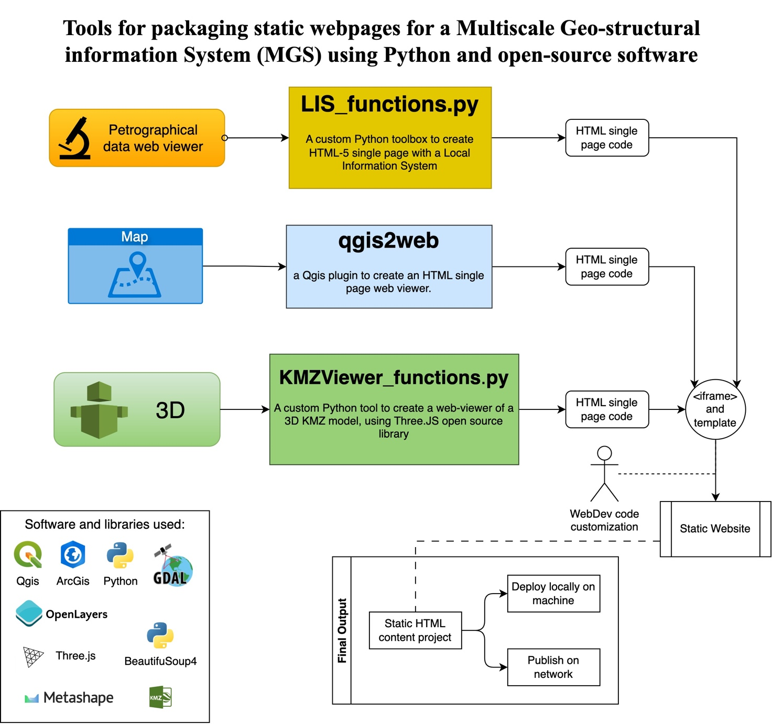

Figure Tools and process diagram for packaging static webpages for Multiscale Geo-structural information System (MGS)

Using all the above considerations, it is possible to propose a unique methodology for the realization of a Multiscale Geo-Structural (MGS) Web-GIS. The approach integrates various ad-hoc developed tools and open source software to create static websites that effectively display geographic data in an interactive manner, as displayed in Figure 2. Three primary tools are utilized for processing and visualization:

1. **Petrographical data web viewer:** using acustom Python toolbox developed in this work (i.e., “LIS\_functions.py”), designed to generate an HTML5 single-page Local Information web viewer developed in this work.
2. **Map (cartographic data):** the popular*qgis2web* QGIS plugin that facilitates the creation of a single-page web viewer directly from geographic data (Duarte *et al.*, 2021).
3. **3D models:** using a custom Python tool developed in this work (i.e., “KMZViewer\_functions.py”), leveraging the Three.js open-source library to create 3D KMZ model visualizations within a web viewer (Danchilla, 2012).

Each tool outputs HTML single-page code, which is subsequently structured using an <iframe> and additional templates. These templates are further refined through manual customization to meet specific visualization needs.

The final static website represents geospatial (and petro-structural) data interactively, using a combination of software and libraries. This workflow demonstrates the seamless integration of advanced tools with web technologies to enhance data accessibility and usability in scientific and educational contexts. This modular approach provides a versatile framework for researchers and developers aiming at representing geospatial data on the web, suitable for an MGS project.

## 2.1 Petrographical data Web-viewer

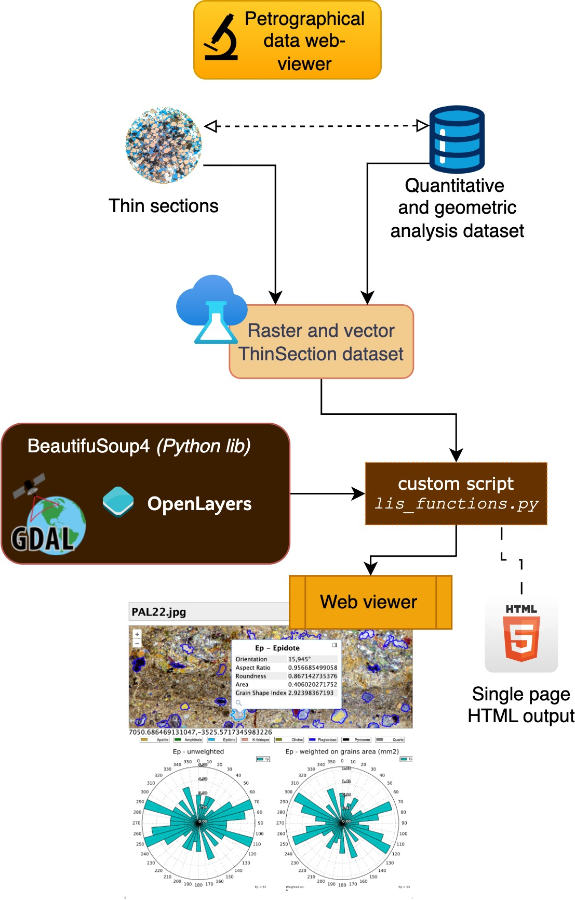

Figure Petrographical data web-viewer features and simplified creation process diagram

Grain size analyses were performed by processing images of thin sections with image sensing algorithms providing vector data that annotate and describe precise elements within the images (Acevedo Zamora *et al.*, 2024; Heilbronner, 2000; Tarquini & Armienti, 2011). Grain classification, shape detection, and vectorization of elements from the rasters results in vector data that is used to describe or represent the results obtained in the processes. (Li *et al.*, 2008; Ortolano *et al.,* 2018; 2021, Visalli *et al.,* 2021).

In a “Microscopic Information System” (Tarquini & Favalli, 2010) these data are referred to a non-geographic and non-spatial reference system. The numerical data of the vertices of the vector primitives and pixel indices of the images are certainly representative in terms of scale, but not in terms of position in space. It is possible to know and define the actual size of an element in this system but not its position in space or in a geographic datum. In the case of thin sections, for example, it is important to know the size in millimeters of an image pixel but not its geographical position at the same scale.

A Python library called “LIS\_functions.py” has been developed, which includes seven functions that allow the construction of a “local information system” of a thin section and the generation of a static website page that is easy to publish and share on the web. The functions can be used in sequence, as described in Table 1 and Figure 4.

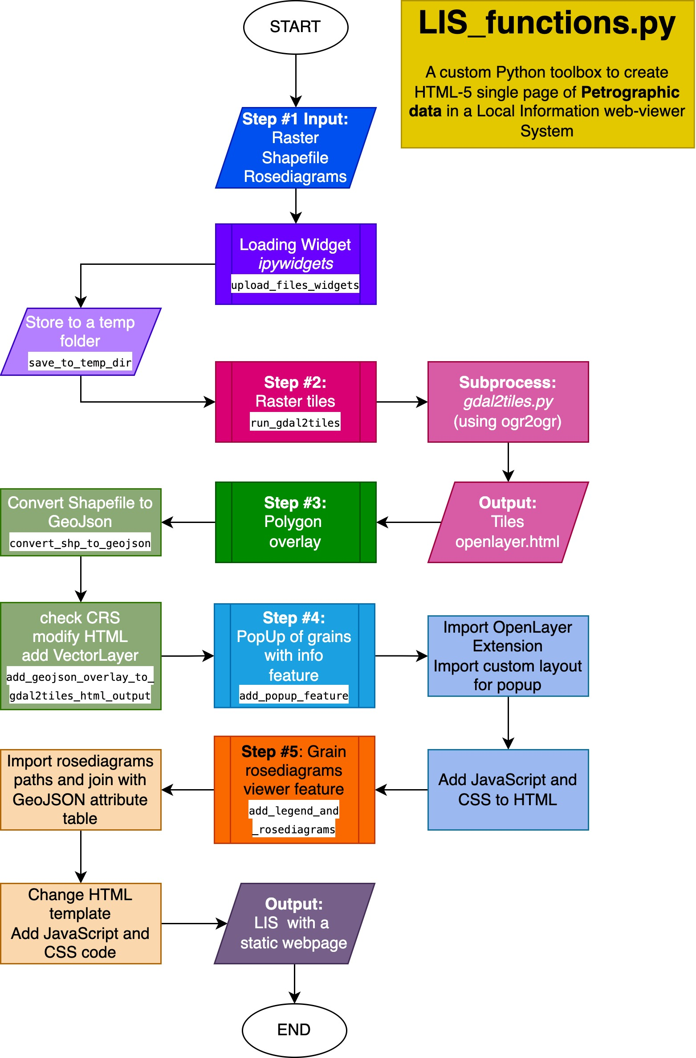

Figure Detailed process for production of a Petrographic data viewer using LIS\_function.py tools

### Step #1: Prepare datasets and environment

In order to launch the first step of the procedure, a raster file of a high-resolution thin section scan must be available, and a polygon features layer that overlays minerals or other elements of the thin section must have been defined. The Raster data has to be a JPG or TIFF file depicting an RGB image of the thin section. The feature layer must be a shapefile and its polygons must correctly overlay the raster in a no-CRS system.

Environment requirements are very simple:

* Python >= v.3.11
* GDAL >= v.3.8.5
* Python libraries: *os, subprocess, bs4/BeautifulSoup* easily installable via pip manager
* Computational notebook: Jupyter with *IPython.display, ipywidgets* libraries

When using Shapefiles, the minimum collection of 4 files [.shp, .dbf, .shx, .cpg] in ESRI standard format must be provided. The shapefile will be converted in GeoJSON format by an `ogr2ogr` subprocess inside the Python environment. The Shapefile used as input for data visualization must contain polygons of mineral of the thin section and an attribute table with fields described in Table 2 Starting by using the functions *upload\_files\_widgets* and *save\_to\_temp\_dir* inside a Jupyter Notebook, it is possible to launch the process; users can select from the device storage the Raster and Shapefile to use for LIS generation.

### Step #2: Raster tiles creation

In order to enable more efficient rendering in the user's browser, the display of large raster-type images of thin sections was achieved by generating tile layers. Tile map layers are constructed by subdividing a raster image into numerous small portions at different zoom scales (tiles), through the use of *gdal2tile*s.*py* (McInerney & Kempeneers, 2015), while maintaining the original raster characteristics. The individual tiles are saved in a folder structured as */{zoomlevel}/{x}/{y}.png* convention; where the value of “z” is a zoom level for *webviewer*, “x” and “y” are the coordinates of the tiles points obtained by procedure of subdivision of raster. The browser, depending on the zoom and pan commands provided by the user during navigation, builds the strings of tile paths to be used and loads into memory only the needed data. An equivalent of the *gdal2tile*s.*py* subprocess is also used in QGIS with the native plugin called *tilesxyzdirectory*. Using these sub-processes is important to keep the user as much as possible within the comfort zone of known tools (Baumann *et al.*, 2021). Given the large number of files generated for these cases, it is convenient to upload them to the Web within free or low-cost file hosting services such as Amazon's AWS-S3 (Han, 2015).

The function of the *LIS\_functions.py* toolbox that operates with *gdal2tiles.py* is called *run\_gdal2tiles*. This function opens a new subprocess in the Python environment that calls an *ogr2ogr* instance; this last runs the *gdal2tiles.py* procedure using the output of the previous step as input.

At the end of elaboration, a folder will be generated, containing the tiles and a simple html file (named *openlayers.html*) with a web viewer of raster inside. By default, *ogr2ogr* uses OpenLayers Javascript and CSS tools (Steiniger & Hunter, 2013). An example of output is illustrated in Figure 5.

### A single page web viewer generated using run_gdal2tiles function Step #3: Add Mineral polygons overlay

Figure The web view of result of Step #2 of Petrographic data viewer creation process using LIS\_functions.py tools

In this step, the Python function “*add\_geojson\_overlay\_to\_gdal2tiles\_html\_output”* accesses the *openlayers.html* file, already described as the output of Step#2, and changes JS and CSS code to introduce the capability of overlaying the vector polygon layer on the raster tiles in the web viewer. By taking advantage of the Python library *BeautifulSoup*, the html is parsed into an object manageable in the Python environment, and then the required new code is added. In particular, the function incorporatesJavascript code works with OpenLayers JS library for overlaying a GeoJSON vector object. Considering that we are operating at a micro-scale and that the raster and vector coordinates lack an established reference system, we assume that all coordinates are assigned in a nominal, fictitious CRS, such as PseudoMercator (EPSG:3857) (Markieta & Rinner, 2014), for both a proper map overlay and correct functionality of the Web-GIS. This condition is necessary to obtain from OpenLayers (or a similar library) the capability of viewing and overlaying these geospatial data in a webpage, and it only works if the vector layer and the raster layer are already overlaid in a no-CRS representation.

This function produces as output another html file (or an updated version of the previous html file) with the specified functionality fully implemented and operational, an example is illustrated in Figure 6.

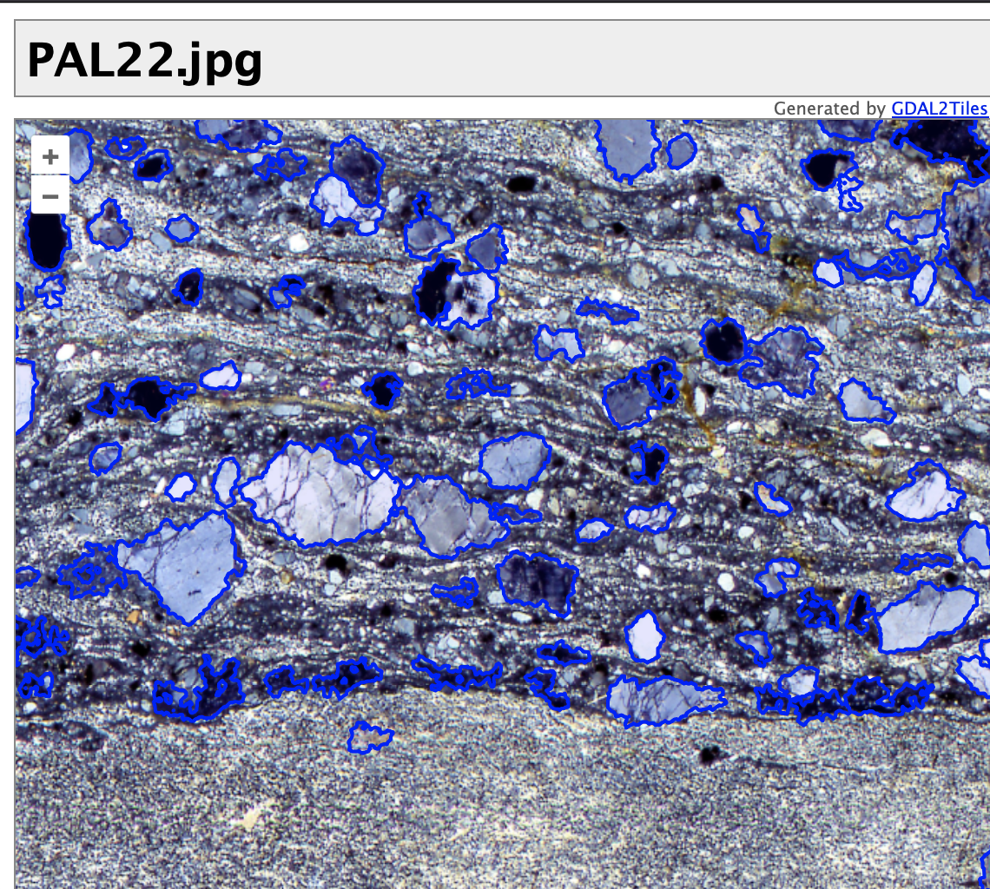

Figure The web view result of Step #3 of Petrographic data viewer creation process using LIS\_functions.py tools, vector grain boundary overlay in the thin section raster data.

### Step #4: Add pop-up feature

Within the Python environment used for the proposed methodology, it is possible to access and modify the HTML code obtained in the previous step to add a pop-up feature. A commonly used pop-up functionality in OpenLayers is provided by “OpenLayer Extension”, also known as *ol-ext* (Viglino, 2024). The proposed function, called“*add\_popup\_feature*”, modifies the html file generated in the previous step. Firstly, it adds a link to JS and CSS of *ol-ext* code provided by a Content Delivery Network (Vakali & Pallis, 2003). The function was implemented using a simple scheme to display the pop-up, by leveraging the *ol.Overlay.Popup* method in Javascript, as shown in the following code.

*Template JavaScript code for PopUp feature*

var popup = new ol.Overlay.PopupFeature({

popupClass: 'default anim',

select: select,

canFix: true,

template: {

title:

// 'nom', // only display the name

function(f) {

return f.get('Mineral') + ' - ' + getMineralName(f.get('Mineral'));

},

attributes: //

{

'O' : {

title: 'Orientation',

before:'',

format: ol.Overlay.PopupFeature.localString(), // format as local string APPROX

after:'°'

},

'AsR' : { title: 'Aspect Ratio' },

'R': { title: 'Roundness' },

'A': { title: 'Area' },

'GSI': {title: 'Grain Shape Index'} // ,

}

}

});

Then, another function included in the JavaScript template, called “*getMineralName*”, returns the extended name of the mineral to be inserted in the title bar of the pop-up window, retrieving it from the encoded name in the GeoJSON or source vector data, as described in Table 2.

### Step #5: Incorporating Mineral Legends and Rose Diagrams

In this step, we enhance the web map with an additional layer of customization by incorporating mineral-specific legends and rose diagrams about orientations of the recognized objects (e.g., clasts/grains/voids/pores). Using ArcStereoNet (Ortolano *et al.*, 2021) or other microstructural analysis software for thin section data, we generated rose diagrams both unweighted and weighted on the cumulative area of mineral grains.

The diagrams, stored in SVG format within *\asset\rose*, are configured to allow user interaction within the web map interface. Specifically, each user interaction with a polygon classified as a particular mineral (e.g., "Quartz") triggers the display of the corresponding rose diagram. To support this feature, additional functionality allows users to query rose diagram results by selecting buttons representing different mineral types. To each mineral type, classified within the thin section, is assigned a button created with graphic software and saved in *\asset\legend*.

The proposed function “*add\_legend\_and\_rosediagrams*” (part of *LIS\_functions.py*) modifies the HTML generated in previous steps as follows:

1. Copies files for rose diagrams and legend buttons into the appropriate subdirectory.
2. Adds a “blank rose diagram” to represent cases where a query returns “other” or no mineral-specific data.
3. Insert necessary JavaScript code and HTML tags for the legends and rose diagrams.
4. Adjusts the map’s height and modifies additional style and script settings to optimize display.

The *add\_legend\_and\_rosediagrams* function is designed to handle a list of file paths for both rose diagrams and legend buttons. An example of the result obtained after executing the function is shown in Figure 7.

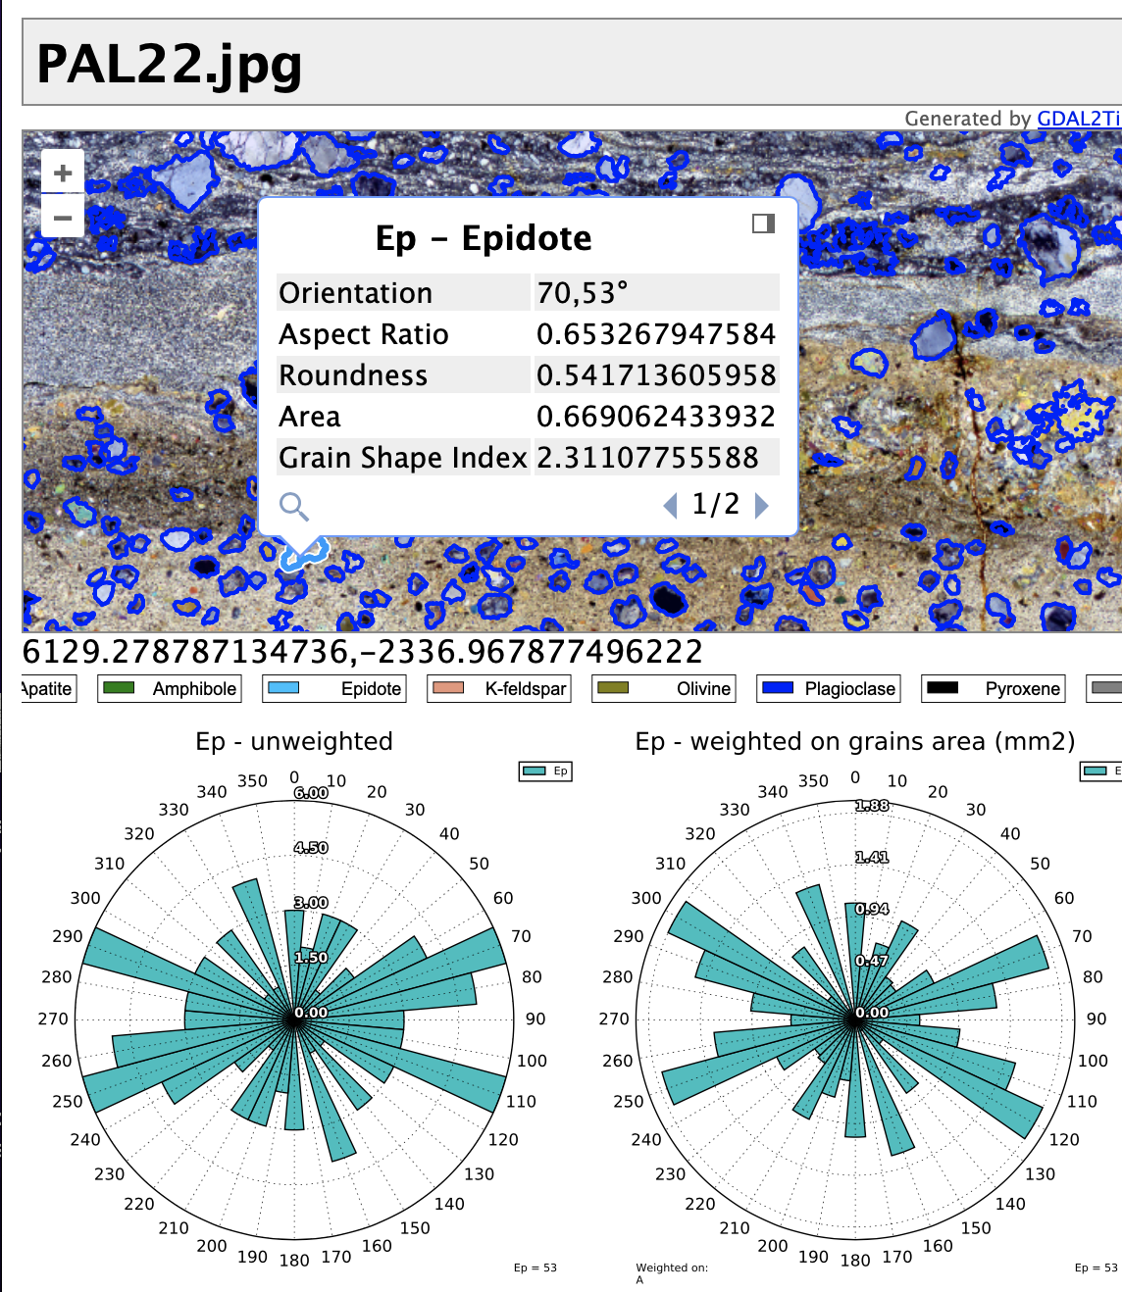

Figure Output web view after the final "add\_legend\_and\_rosediagrams" procedure in LIS\_functions.py library sequence. Users can access specific mineral grain properties of a single grain (polygon appears with an highlighted boundary) and global statistics. A visual representation of mineral grains orientation is provided through rose diagram charts, both unweighted (concentric circles indicates cumulative number of grains) and weighted on grains area (concentric circles indicates cumulative area of grains in mm2).

## Three-dimensional model web viewer

The representation of three-dimensional objects on the Web is done by using 3D rendering libraries of geometric models. The most widely used free and open source project is Three.JS (Danchilla, 2012), which offers the ability to handle raw geometric data and models saved in standard formats. Exporting a three-dimensional geographic model into a website using Three.js is a feature already available in QGIS with the *qgis2threejs* plugin, which is used in applications like buildings 3D visualization (Maestri, 2017). If data comes from other sources such as point clouds, models generated by Structure for Motion algorithms, or 3D models of microscopic structures, it is possible to take advantage of some modules of the Three.JS library for displaying files containing the models.

Inside Three.JS Library a module called “KMZ Loader” allows loading a file of a complex 3D model stored in a KMZ file. The Keyhole Markup Language Zipped File (KMZ) (Burggraf, 2015) is a ZIP archive file with models, overlays, tiles, texture, images, icons, and other network-linked KML (Keyhole Markup Language) files, all stored in a \*.KMZ file. KMZ files are created using the standard ZIP algorithm. The KML and KMZ can embed a COLLADA type 3D model (Arnaud & Barnes, 2006), an XML-based schema that facilitates the lossless exchange of 3D assets between various 3D modeling and rendering applications (Preda *et al.*, 2010). A KMZ data package therefore can contain complex 3D models, textures, and additional elements. Export to KMZ or COLLADA format is a widely used feature in most “Structure from Motion” software, such as Agisoft Metashape (Rahman & Cahyono, 2023). KMZ files extremely reduce the inputs that must be entered into JavaScript code to display a 3D model.

To complete the procedure, just the relative position inside the scene has to be defined and, optionally, a few default settings for lighting and other rendering features may be tweaked. It is also relatively simple to develop a script that generates an HTML element with a pre-configured viewer for a 3D Model. A flow chart of the proposed methodology related to generating a static web page to display a KMZ model is illustrated in Figure 8.

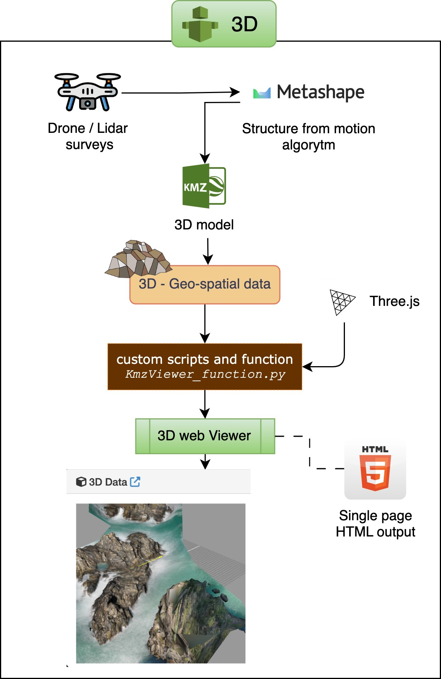Compared with the procedure explained in the previous paragraph, the HTML code of a static web page in this case is simpler. By taking advantage of the Python environment, an HTML template that included the required JavaScript and CSS libraries was generated. Within the template, variables managed by Python were added, which will be replaced with the processed HTML code. Inside a module called “KMZViewer\_function.py” there are a collection of string variables storing the HTML structure of a 3D model viewer, along with auxiliary functions. A detailed list of function is reported in Table 3 Leveraging Python, this structure facilitates the dynamic generation of customized HTML, tailored to specific input data.

Figure 8 The 3D geological models web viewer features and simplified creation process

To enhance visualization, several essential customizations should be applied to each specific model:

* Define or adjust the custom coordinates for the model's central position, utilizing the *KMZLoader* JavaScript function.
* Define or adjust the custom coordinates for the camera's center using the *THREE.PerspectiveCamera* JavaScript function.
* Configure appropriate lighting and rendering options.

These modifications are best implemented directly within the HTML/JavaScript code, following the generation of the initial HTML structure through Python. Identifying and fine-tuning the specific coordinate values and other variables is a straightforward process within this framework.

Using a Jupyter in a Python environment it is possible to activate all of functions and variables in Table 3 are called by the “*create\_3dml\_viewer()”* method, which in turn takes as input 3 elements:

* Name of the project
* KMZ file
* Splashscreen image

An example of simplified GUI for input file loading inside a Jupyter Notebook is illustrated in Figure 9.

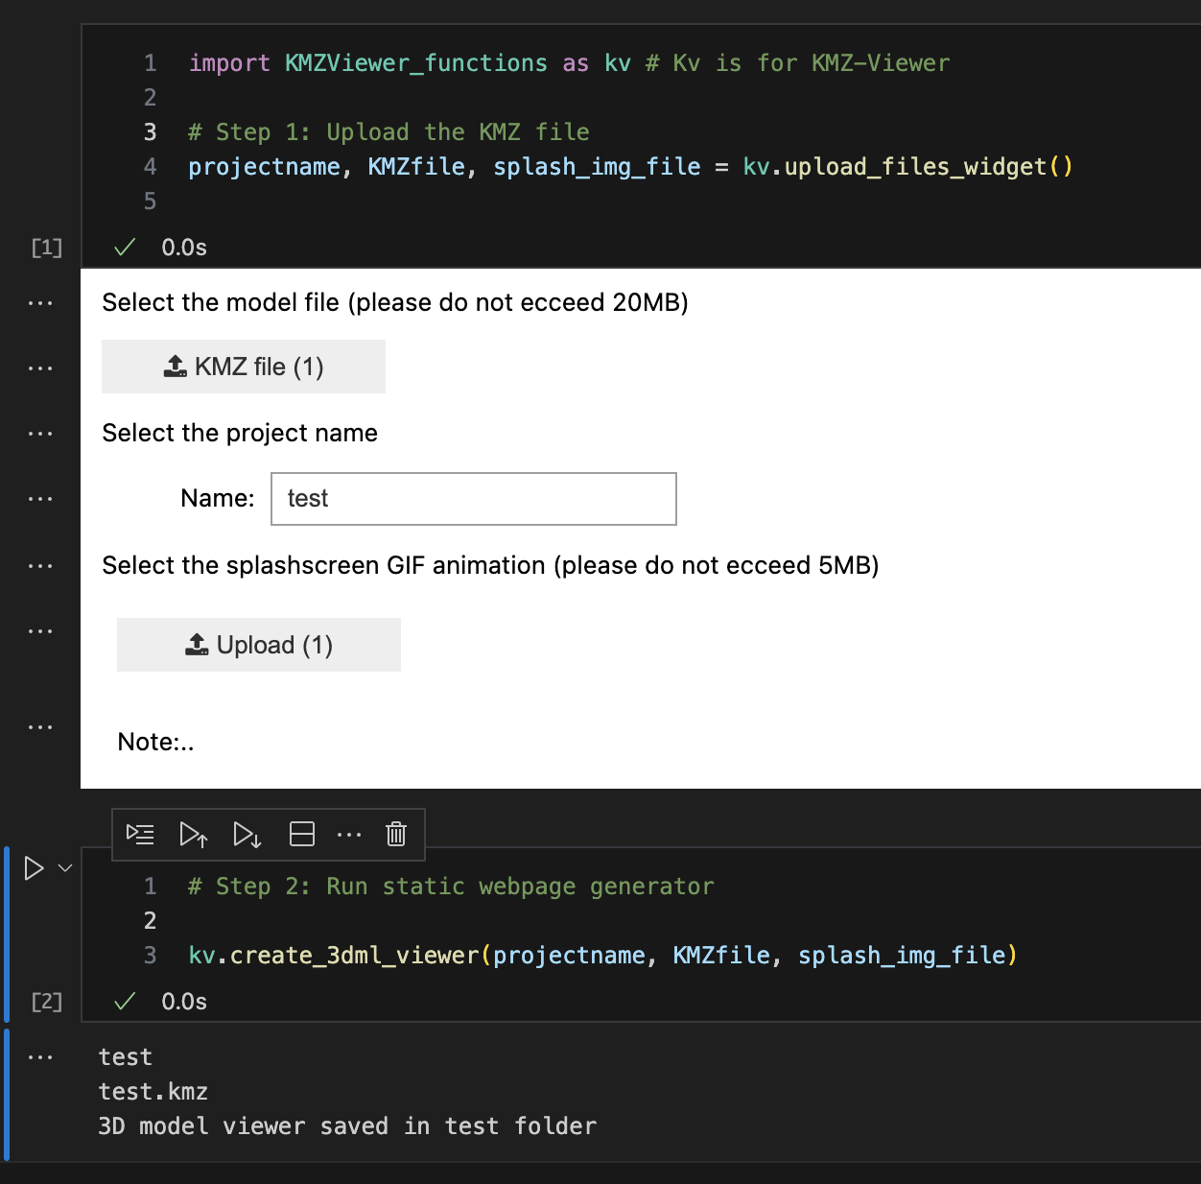

Figure A Jupyter-notebook interface with the only two steps required to create a web-viewer static page of a KMZ file using the KMZViewer\_function.py

The output folder is named with the same name assigned to the project, and contains:

* an html file with web viewer;
* the KMZ file provided in input;
* the splashscreen image provided in input;
* a subfolder called “*three*”.

Due to the inherent limitations of Content Delivery Networks (CDNs) in efficiently serving these specific files, and in order to mitigate potential issues arising from Cross-Origin Resource Sharing (CORS) restrictions, a preferred strategy is to store and retrieve the required files locally within the KMZ model file (Hossain, 2014).

The */three* subfolder contain add-ons and other JavaScript files imported from the Three.js project. These files are downloaded from the Three.js repository and are organized to maintain the default structure of the Three.js framework. Specifically, they are stored within the directory *three/addons/jsm*, which contains the following subfolders:

* *three/addons/jsm/controls*: Contains the *OrbitControls* module, enabling navigation features for 3D scenes.
* *three/addons/jsm/libs*: Includes the *fflate* module, a fast JavaScript compression/decompression library designed to enhance rendering speed.
* *three/addons/jsm/loaders*: Contains the *ColladaLoader*, *KMZLoader*, and *TGALoader* modules for loading respective file types within the Three.js environment.

An example of output web-viewer in a <iframe> HTML element is illustrated in Figure 10.

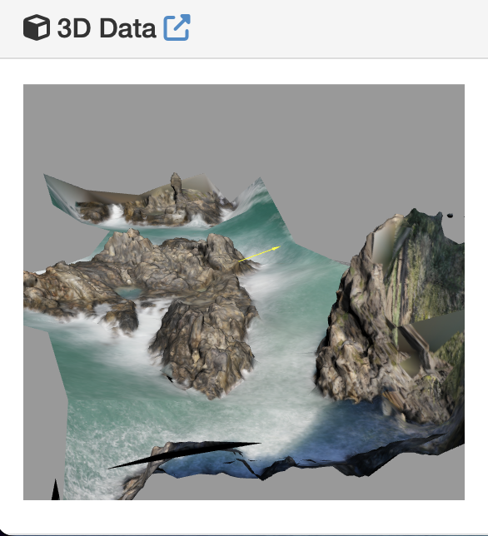

Figure Output web view of a 3D model using KMZviewer\_functions.py

## Geo-graphical and maps data viewer

With the same approach, geographic data visualizers and online maps can be generated by taking advantage of the capabilities offered by the OpenLayers library. A quick view of creation process is illustrated in Figure 11. QGIS community offers several plug-in and tools to generate web maps (Duarte *et al.*, 2021); for instance, *qgis2web* is capable of exporting an entire map project, with all graphic textures to a folder with files for publication on the web. This procedure is straightforward and requires at most a few corrective operations for displaying the data. This method of publishing is used by geospatial scientists for various types of maps (Azmi *et al.*, 2022; Bachri *et al.*, 2022) and is a common way to obtain a static web page with several features.

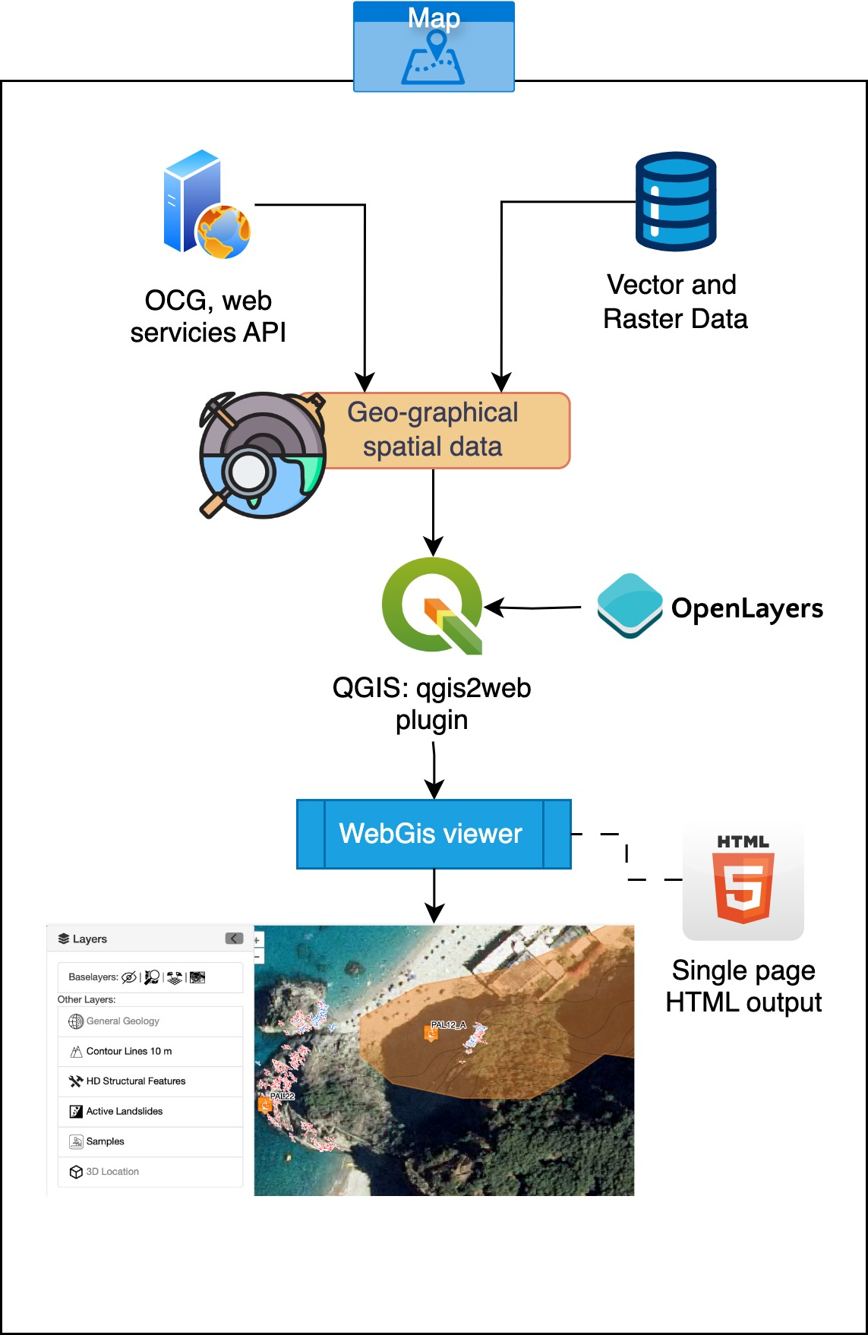

Figure Geographical and maps data viewer features and creation process

## Merging multiple data web-viewers in an MGS website

The realization of an integrated MGS data visualizer, as revealed by the analysis conducted, can be achieved through the synergistic use of the Bootstrap framework and *<iframe>* tags (Cheng, 2024). This approach, geared toward modularity and efficiency, involves the definition of a web layout optimized in terms of User Experience (UX) and User Interface (UI). In this context, UX plays a key role in ensuring viewer usability and accessibility. An effective UX results in an intuitive and satisfying user experience (Visser *et al.*, 2019), characterized by:

* Clarity: information must be presented clearly and concisely, facilitating understanding of the data displayed.
* Efficiency: interaction with the viewer should be smooth and intuitive, allowing the user to achieve their goals quickly and effectively.
* Consistency: the design and functionality of the viewer must be consistent across sections and with established web interaction conventions.
* Accessibility: the viewer must be accessible to all users, including those with disabilities, through the implementation of specific functionality and the adoption of web accessibility standards.

The UI, in turn, contributes significantly to the communicative effectiveness of the viewer. A well-designed UI (Norman, 2013) is distinguished by:

* Aesthetics: the visual appearance of the viewer should be neat and appealing, stimulating user interest and promoting data exploration.
* Organization: graphical elements and controls must be arranged in a logical and intuitive manner, guiding the user in interacting with the viewer.
* Feedback: the viewer must provide clear and timely feedback to user actions, confirming successful interaction and preventing errors.
* Responsiveness: the design of the viewer must adapt dynamically to different screen sizes and resolutions, ensuring an optimal user experience on any device.

The design of an integrated geoscience data visualizer requires careful consideration of UX and UI aspects. Effective synergy between these two elements results in a positive user experience that promotes understanding and analysis of geoscientific data.

The HTML standards and scripting languages allow different ways of merging parts from different sources (Simon, 2023), the simplest, but not the best performer way of combining one web page with its attachments within a frame of another is the use of the <iframe> tag. In this proposed methodology, which has as one of its goals to simplify the engineering process, embedding methods that could offer more effective performance by taking advantage of code refactor and optimization of all embedded scripts and libraries (Li & Zhang, 2021) have been left out.

It is possible to combine in a web-template the three data-type frames; Bootstrap streamlines UI development with its ready-to-use components and adaptable grid system, ensuring an optimized visualization on any device. Bootstrap grids are a powerful layout system provided by the Bootstrap framework, which is a popular front-end toolkit for building responsive and mobile-first websites and web applications. The grid system in Bootstrap is based on a 12-column layout, which allows developers to create flexible and responsive designs that adapt to different screen sizes and devices. jQuery simplifies client-side scripting with its intuitive functions for DOM manipulation and other common tasks, providing a friendly way of adding interactive elements to a website or web application. Interactive elements like sliders, accordions, modal dialogs, and animations can improve user experience by engaging users and making the interface more dynamic (Naik & Naik, 2024).

In our example, further described in the “Case Study” section, we organized the components into a hierarchical structure of files and directories. In this process, the use of Bootstrap was crucial in building the layout of the viewer, particularly through its system of “containers”.

Containers in Bootstrap are fundamental elements that allow the content within a web page to be organized and structured (Elrom, 2016). They provide a predefined and responsive area that can automatically adapt to different screen sizes, within which layout elements, such as text, images, tables, and, in our case, multiscale geodata viewers, can be arranged.

Within containers, layout elements are organized using Bootstrap's grid system, based on rows (.row) and columns (.col). The columns, in turn, can be nested to create complex and articulated layouts. In our specific case, <iframe> tags, which include the individual viewers, are placed within these containers and organized via the grid system. This approach provides high flexibility in the arrangement of the viewers and a responsive layout that adapts to different screen sizes. The integration of the independently developed viewers within a structured layout with Bootstrap allows for a combination of development flexibility and design modularity. In addition, the use of <iframe> tags for data visualization ensures effective functional isolation between components, allowing individual visualizers to be updated without impacting the overall website structure.

An example of an integration of three static webpage data viewer for an MGS website process is represented in Figure 12.

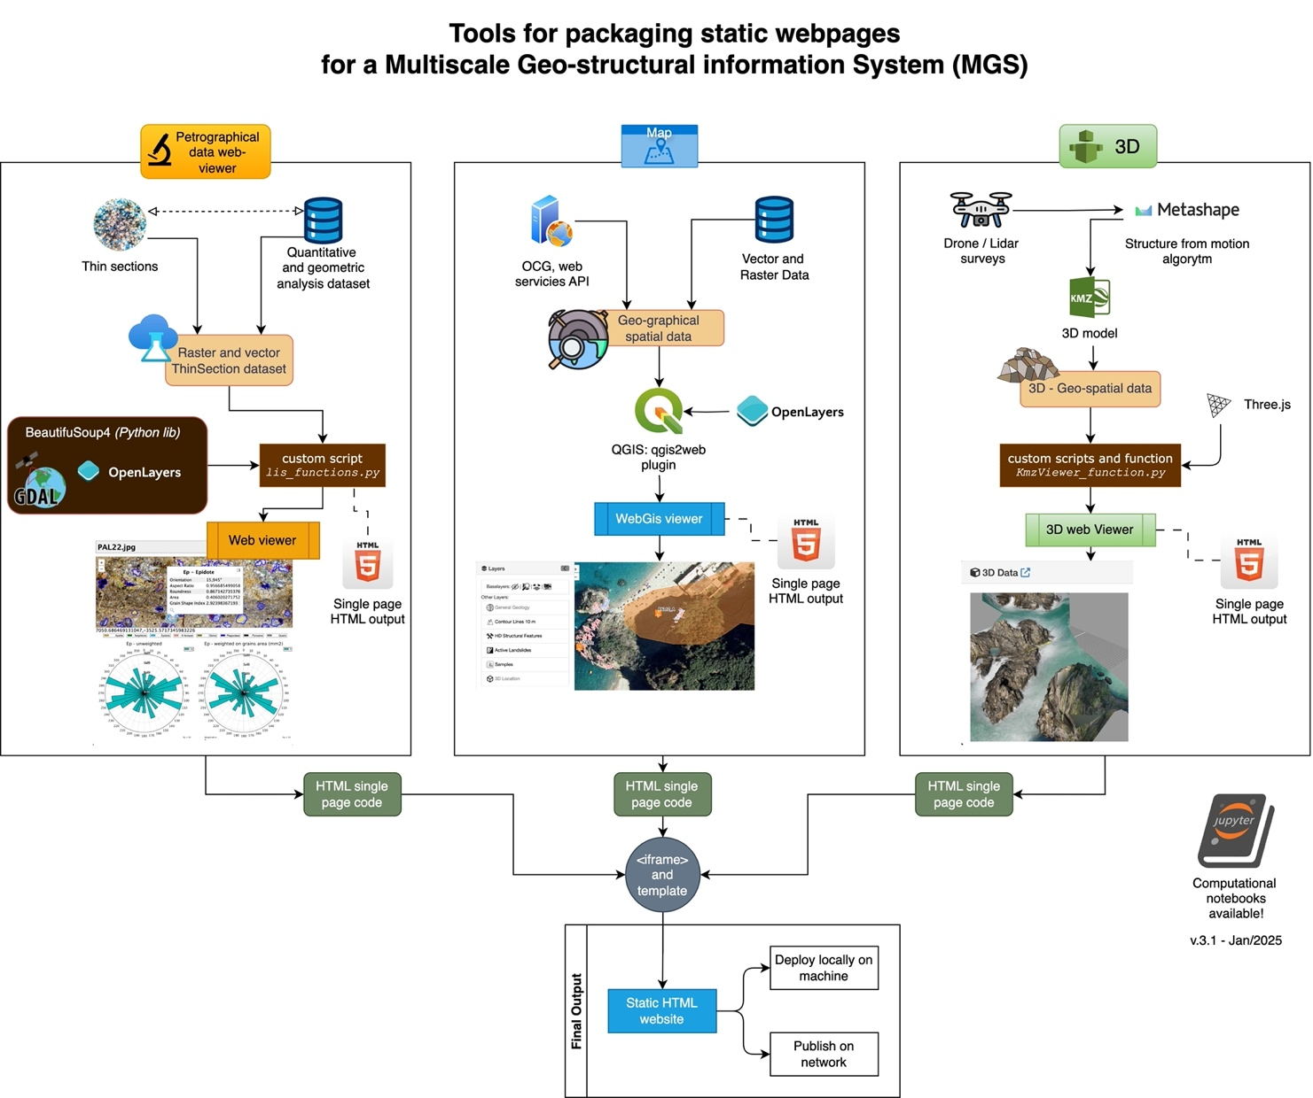

Figure Global diagram for packaging a Multiscale Geo-structural information System (MGS) web viewer features and making process

This methodology, if properly validated through cross-browser and cross-device compatibility testing, profiles as an efficient and scalable solution for creating modular web platforms for geoscientific data visualization and analysis.

# Case Study

The Palmi Shear Zone is located on the Tyrrhenian side of the southern offshoot of the Calabrian coast (Fig. 13a). From a lithological point of view, the backbone of the study area is characterized by crystalline basement rocks, mostly formed during the Hercynian orogenetic processes in a period ranging from the upper Paleozoic up to the Permian-Triassic transition (between about 325 and 290 Ma - Cirrincione *et al.*, 2015; Ortolano *et al.*, 2020; Fazio *et al.*, 2024a), partially covered in basal discordance by a sedimentary sequence aging from the Tortonian up to Holocene (Fig. 13b).

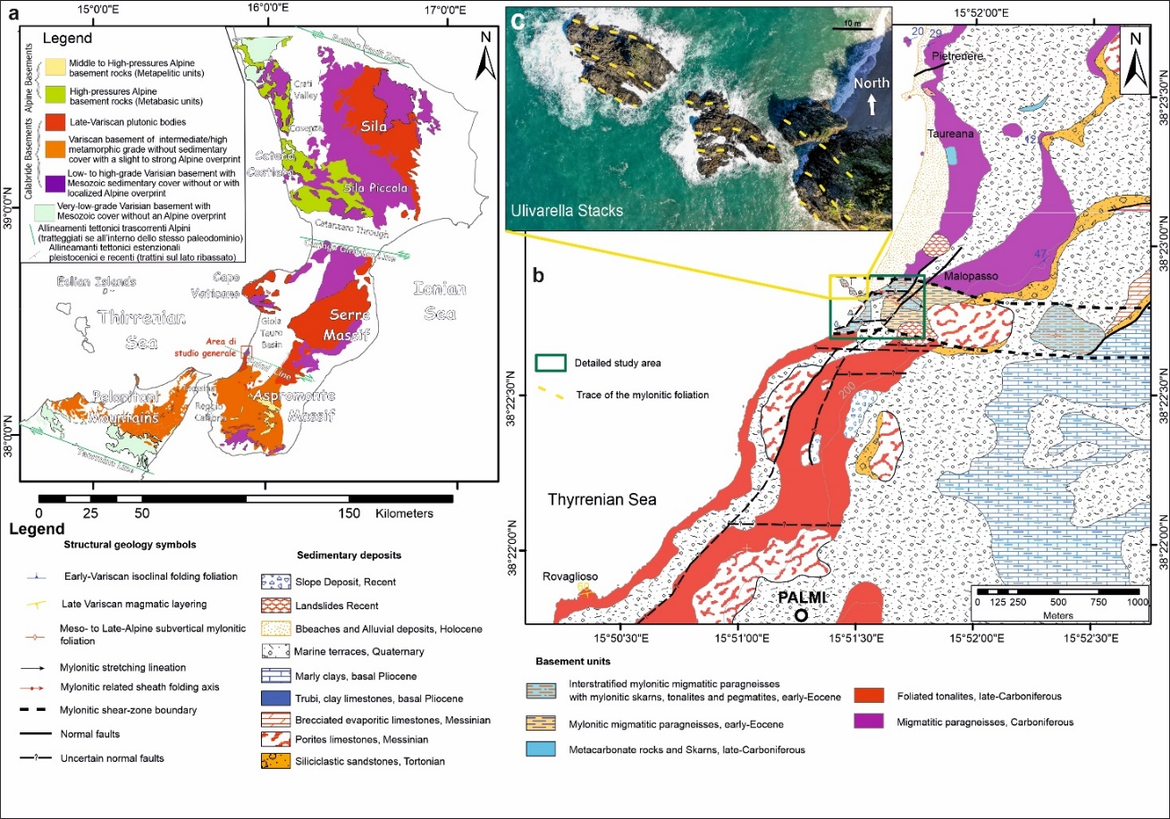

Figure 13 Geological location of the mylonitic rocks outcrop chosen as test site for the Web-GIS development. a) Geological sketch map of the basement rocks forming the Calabrian Peloritani Orogen; b) Geological map of the general study area and location of the detailed study area; c) panoramic view of the Ulvarella stacks with trace of the subvertical mylonitic foliation.

Basement rocks consist mostly of tonalites, represented by the Monte Sant’Elia Massif, and migmatitic paragneiss, outcropping in the inner part of the Taureana waterfront, at the foot of the archaeological site of the “Taureani” (Fig. 13b). Subordinately, it is possible also to observe metacarbonate layers, locally metasomatized, pegmatitic dykes that crosscut tonalites, and migmatitic paragneisses.

From a geological-structural point of view, most of the basement rocks are characterized by a strong tectonic-related fabric (i.e., penetrative and pervasive tectonic-related structures linked with the geodynamic activity). The migmatitic paragneiss is characterized by a main schistosity (e.g. planar penetrative and pervasive structure of tectonic origin along which clear recrystallization is observed - Passchier & Trouw, 2005) connected to an isoclinal folding stage (e.g., folds giving rise to narrow folds with parallel sides - Passchier & Trouw 2005); the tonalites are characterized by a magmatic layering, probably linked to the tectonic control of the late-Hercynian emplacement mechanisms (Russo *et al.*, 2023; Punturo *et al*., 2017).

In correspondence with the Ulivarella stacks, the Hercynian-age-related fabric is abruptly interrupted by a sub-vertical mylonitic-related foliation, where an intense plastic-type deformational activity is observed (Fig. 13b). The sub-vertical foliation is the result of a tectonic process known in the geological literature as “*milonysis*”, a geological process where the rate of strain and the rate of recovery counterbalance each other without one taking over from the other (Wise *et al.*, 1984).

These conditions often form good kinematic indicators known as porphyroclasts (i.e., rigid objects that rotate within a plastically deforming medium). The study of these rocks can then provide precious information about the kinematic mechanism that gave rise to the deformation itself (e.g., Xypolias *et al.*, 2010), allowing the reconstruction of past geological kinematics and contributing significantly to the geodynamic reconstruction of the past tectonic realms (e.g., Ortolano *et al.*, 2020; Fazio *et al.*, 2024a).

Generally, the mylonites of the Palmi Shear Zone show evidences of a pervasive plastic deformation that was generated from about 60 and up to about 40 Ma during the Paleocene-Eocene transition (Prosser *et al.*, 2003) along predominantly strike-slip tectonics (Prosser *et al.*, 2003; Ortolano *et al.*, 2013, 2020; Fazio *et al.*, 2024a).

As already abovementioned, at the Ulivarella stacks and along the portion of the beach in front of the stacks themselves (Figs. 13b, c, 14), it is possible to observe how tonalites and migmatitic paragneisses, originally characterized by sub-horizontal related fabrics, are abruptly interrupted by a sub-vertical mylonitic-related fabric, rheologically controlled by the ductile deformation of metacarbonate layers.

*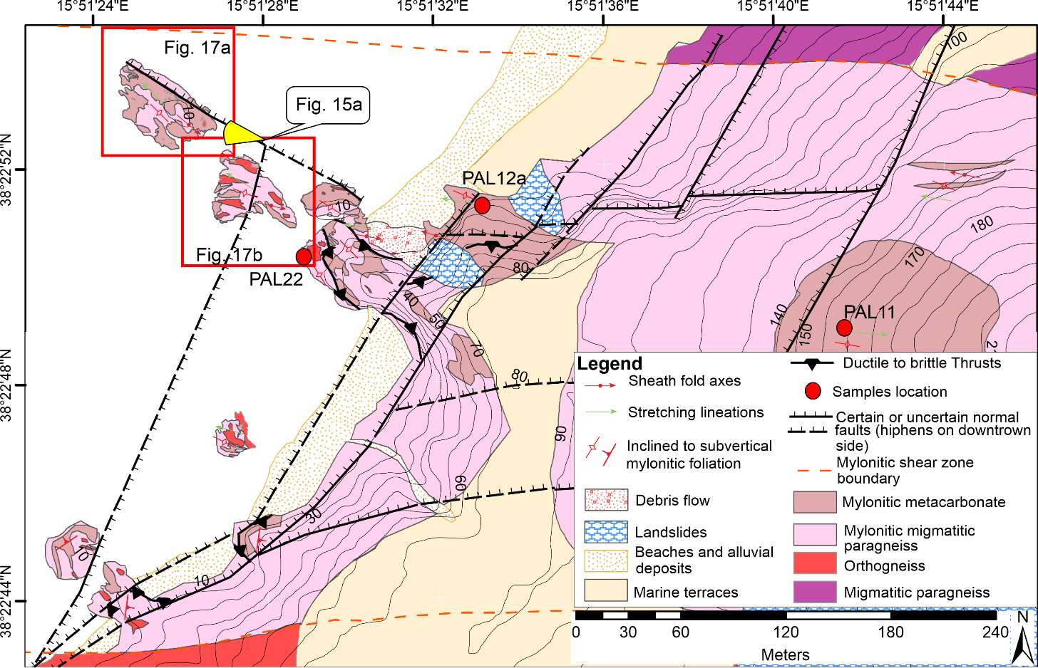*

Figure 14 Structural geological map of the detailed study area chosen as test site for the Web-GIS development.

These meta-carbonate layers have driven most of the plastic deformation due to the mylonitic process, acting as a highly plastic medium within which pieces of tonalites and paragneiss maintained a relatively rigid deformational behavior, forming hundreds, if not thousands, of porphyroclasts of various sizes (Fig. 15).

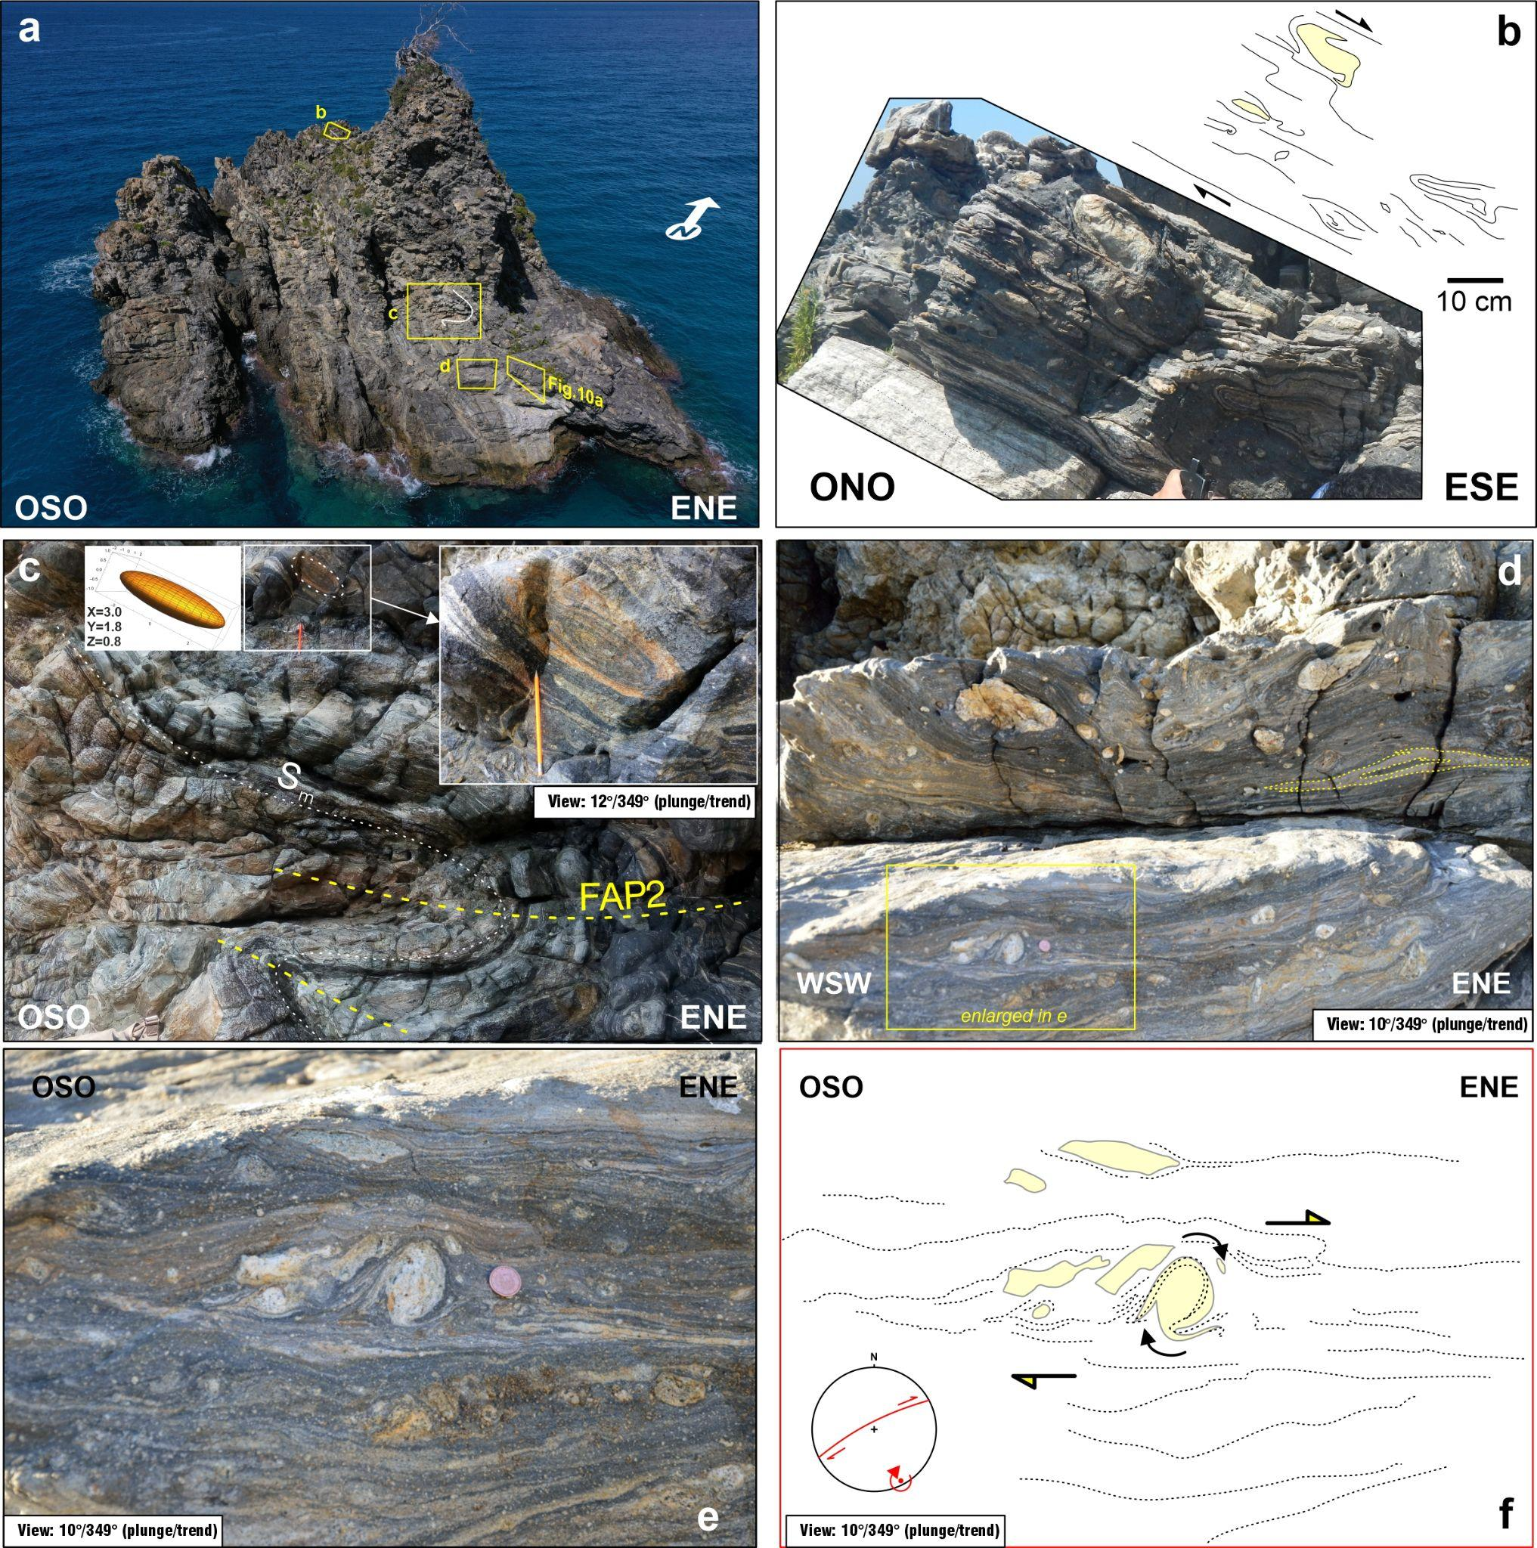

Figure From Fazio et al. (2024a): a) Panoramic view of the most far Ulivarella Stack from the beach; b) Ultramylonitic layer developed at the expenses of the migmatitic paragneisses and of the metacarbonate rocks (upper dark layer); c) sheath fold in the upper limb of a metric fold (FAP2); d) vertical surface of outcrop with a dextrally-sheared sheath fold and several clasts displaying opposite shear sense; e) clast indicating top-to-the-ENE shear sense; f) interpretation of structures depicted in (e); the inset shows a stereoplot with location of a clockwise vorticity axis compatible with the clast at the center of the picture (after Fazio et al., 2024a).

According to Cirrincione *et al.* (2015), this shear zone represents the deepest piece of a more complex strike-slip tectonic alignment known as the Palmi Line, which has driven, along with other sub-vertical crustal-scale strike-slip tectonic structures, such as the Sardinia Balearic Shear Zone (SBSZ), the separation of the Calabrian microplate from the Sardinian-Corsica block, contributing to the rising of the so-called Calabrian Peloritani Orogen (CPO) (Fig.16).

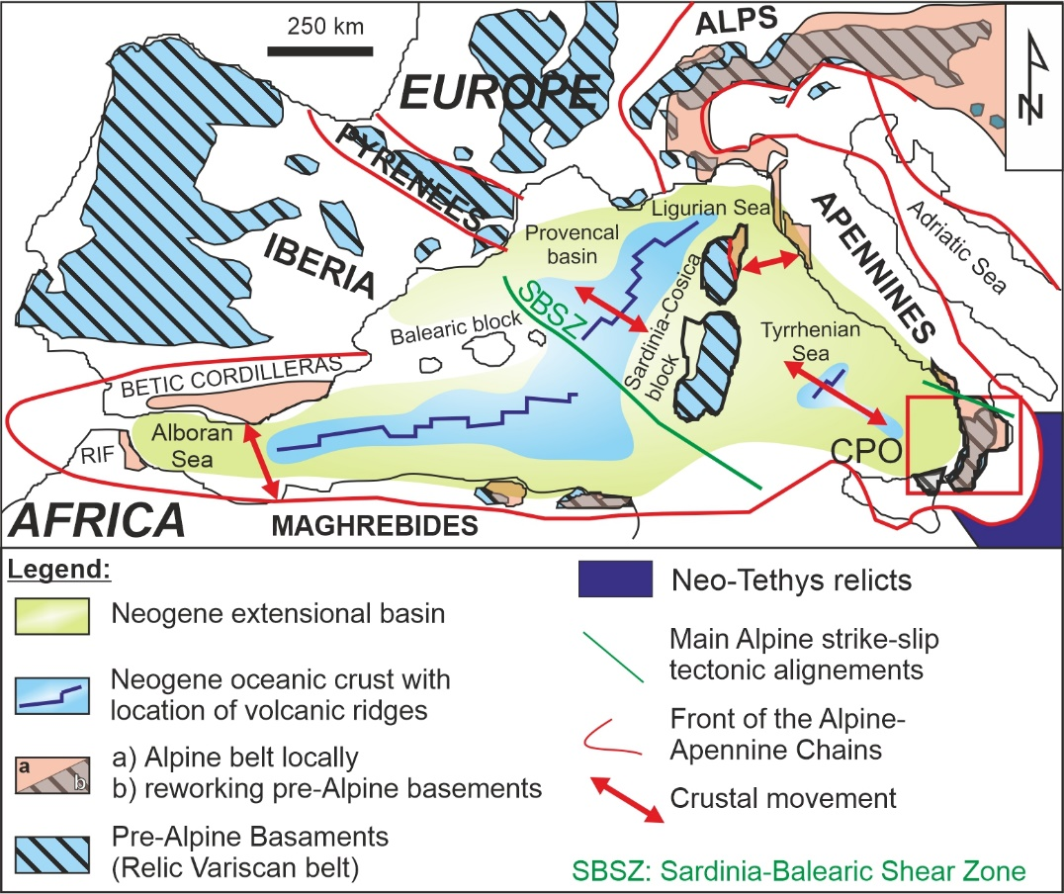

Figure : Present-day distribution of the Alpine and Pre-Alpine Basement in western Mediterranean realm with CPO location and main Alpine strike-slip tectonic alignment (modified after Cirrincione et al., 2015).

The geological-structural study of mylonites implies the necessity to observe all the tectonic-related structures developed at all scales of observations, from the outcrop-scale up to the micro-scale and sometimes also to the nano-scale (Mamtani, 2025).

In our case study, the mylonites of the Palmi Shear Zone were previously studied at the micro-scale through the sequential combined use of two semi-automated GIS-based procedures (i.e., Ortolano *et al.*, 2018; Visalli *et al.*, 2021), able to extract quantitative structural parameters at the thin-section scale (Ortolano *et al.*, 2020) and at the outcrop-scale through UAV surveys (Fazio *et al.*, 2024a), using in sequence the software cloud-compare to extrapolate the 3D model (Thiele *et al.*, 2017) and the software GeoVis3D (Vasuki *et al.*, 2014; Tavani *et al.*, 2024) for the extrapolation of the structural attitudes from the 3D model (Fazio *et al.*, 2024a). Finally, structural-related features at the outcrop- and micro-scale have been projected as lower hemisphere stereographic projection and as rose diagrams of the porphiroclasts orientation, respectively, using the software ArcStereoNet (Ortolano *et al.*, 2021).

The steeply dipping cliff along the Palmi coastline as well as the articulated structural features observable along the PSZ outcrops required, indeed, an aerial survey to assist in the field geological mapping and to acquire more robust orientation geological datasets (Fazio *et al.*, 2024a).

For the first-time publication of this Multiscale Geological-Structural (MGS) Web-GIS platform, it was decided to allow the interactive visualization of the 3D model of the Ulivarella stacks, characterized by well-preserved structural features related to the deep-seated mylonitic activity of the PSZ (Fig. 17a, b).

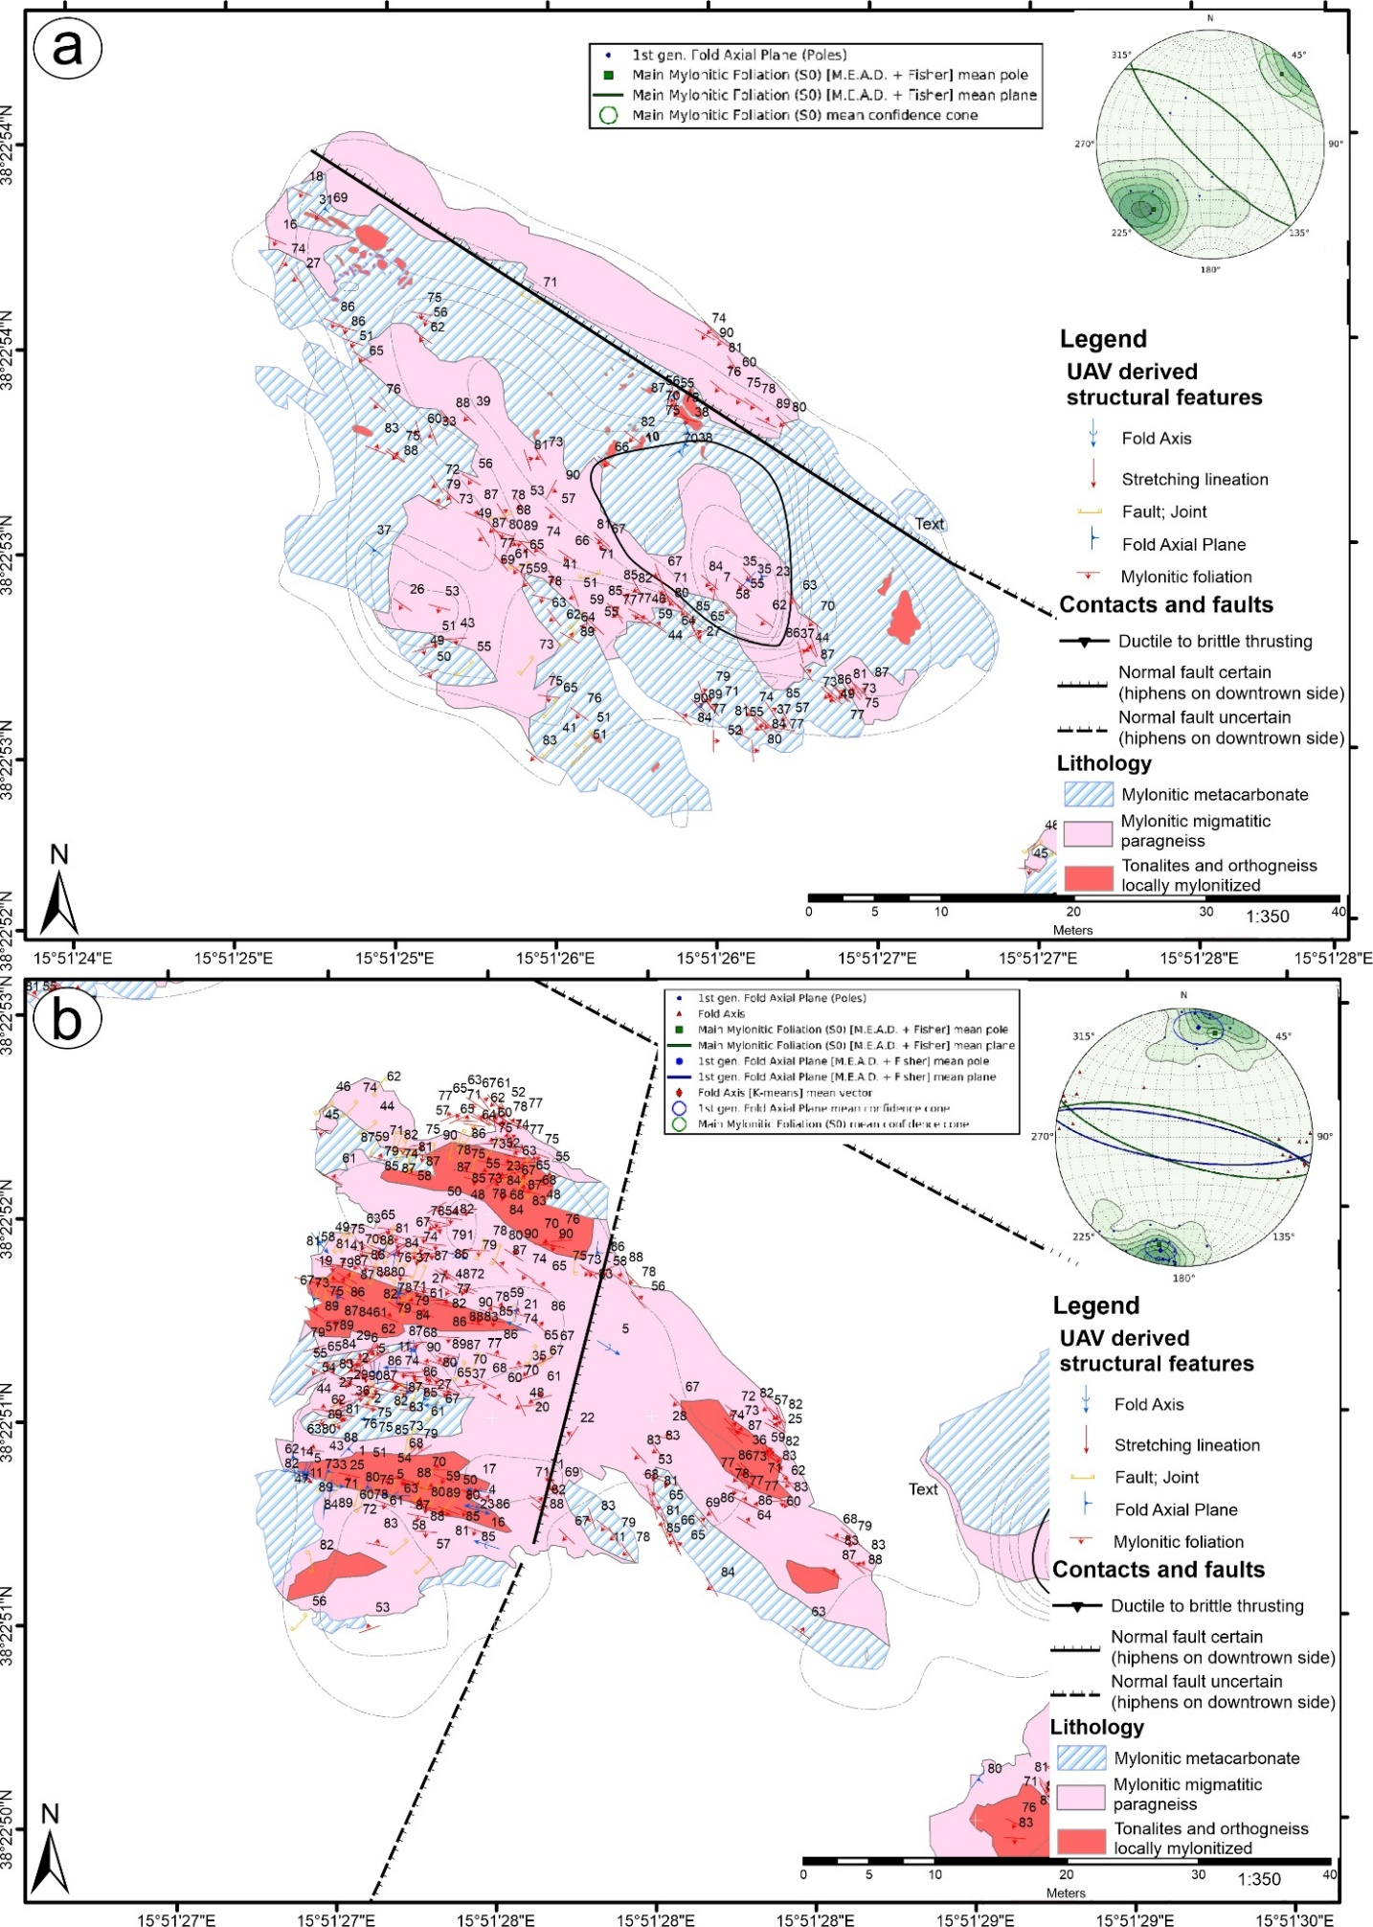

Figure Geological structural maps of the a) Ulivarella Stack 1, and b) Ulivarella Stack 2, derived from the UAV surveys data produced in Fazio et al. (2024a)

Three thin-section samples have then been selected to interactively visualize the micro-structural derived features of the mylonitic process. Specifically, PAL11 is representative of the mylonitic evolution on the migmatitic paragneiss, PAL12a is useful to depict the rheological behavior of the mylonitic metacarbonate rocks, and finally PAL 22 is representative of the mylonitic orthogneiss (Fig.18).

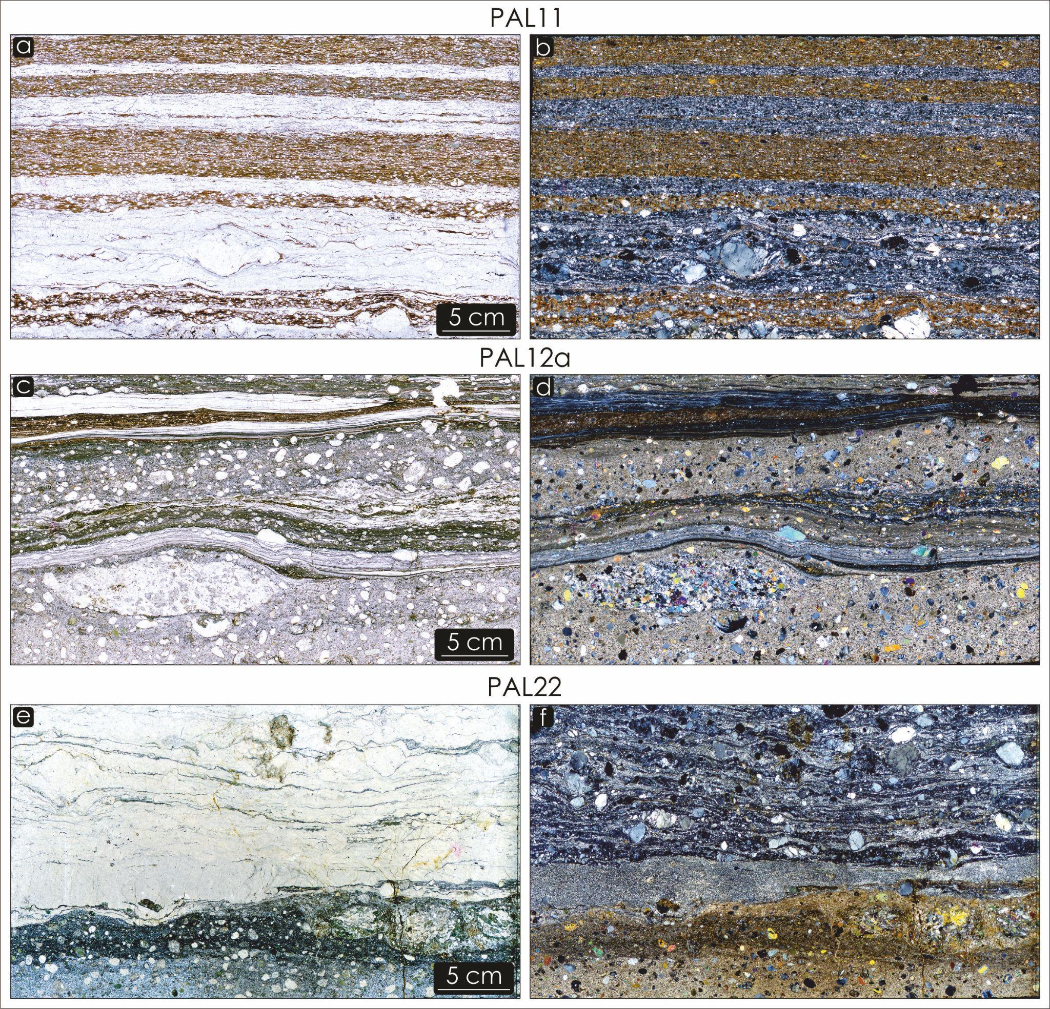

Figure 18 High resolution thin section scans: a,c,e) Plane-polarized Light; b.d.f) Crossed-polarized Light

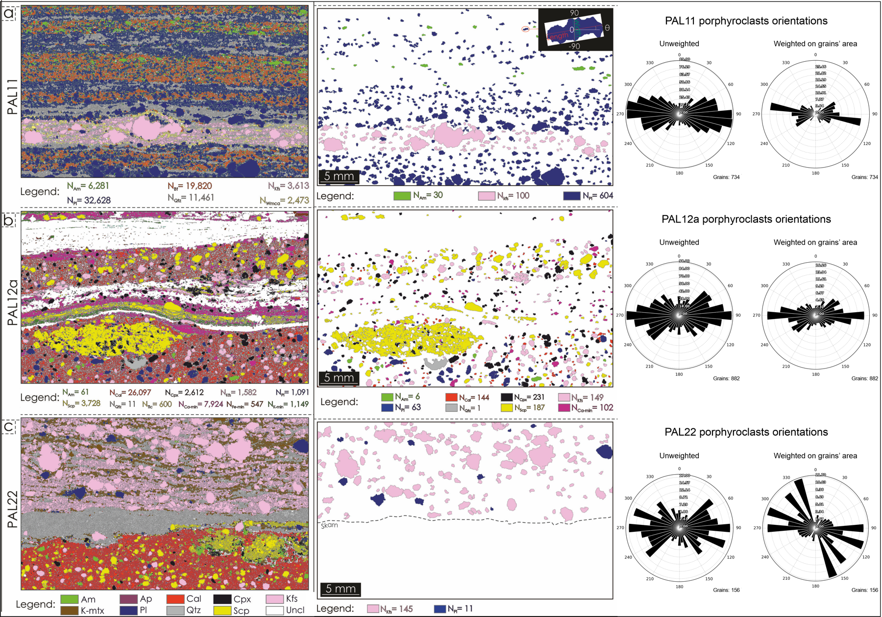

Figure (modified after Ortolano et al., 2020). Mineral phase classification with mineral grain size distribution outputs and distribution of the porphiroclast domains with their relative rose diagrams for: a) PAL11; b) PAL12a; and c) PAL22.

The automatic digitation of the mineral grain constituents via optical high-resolution thin-section scans, together with the classification of the mineral phases via X-ray map analyses, permitted to obtain three distinct classified images (Fig 19). These classified images were used, in turn, to isolate the porphyroclasts, subdivided per mineral type, from the rest of the rock constituents (Fig. 19).

By taking advantage of the method of the minimum bounding box (e.g., Visalli *et al.*, 2021), this last step allowed, in turn, for the generation of both weighted (i.e., normalized to the area of mineral grains) and unweighted rose diagrams (e.g., Ortolano *et al.*, 2021), which display the orientation of the long axis of the classified porphyroclasts. The obtained plots were then exported as SVG images to be used into the MGS Web-GIS platform (Fig. 7).

# Discussions/Conclusions

The digital transition of spatial geo-data is one of the most challenging aims in the framework of the international innovative strategies and the interoperability of data through geoportals is a primary objective. In this view, the present work permitted to obtain differently scaled geo-structural maps on an interoperable web platform where, each point of the sample or model layer has been linked to its own microscale geological dataset and each grain of a specific sample, opportunely vectorized and classified per mineral type, is also characterize by its own fabric related features.

Using the methodology illustrated in previous paragraph, we have conducted an experiment in the case study of the Palmi Shear Zone (southern Calabria, Italy; Fazio *et al.*, 2024a). With the custom Python library “*LIS\_function.py*” It was possible to create the static webpages of three thin-section sample collected and analyzed with mineral data and rose-diagram statistics. The combined use of self-made software useful for the automated classification and vectorization of rock samples at the thin section scale (i.e., Q-XRMA – Ortolano *et al.*, 2018 and MFA – Visalli *et al.*, 2021), permitted to obtain opportunely digitized rock thin sections. In our specific case, the rock thin sections considered for the first multiscale MGS website are *mylonites* opportunely oriented and cut parallel to the stretching lineation and orthogonal with respect the main mylonitic foliation. These rocks are of particular importance within the frame of structural geology study due to its specific petrogenetic process characterized by a relatively high rotational deformation with very scarce recrystallisation process in a constant steady state deformational process without loss of primary cohesion. This implies as these particular types of tectonites are suitable to extrapolate very useful fabric- related parameters and then to reconstruct the kinematics of the deformational process such as for instance those reconstructed by means of the porphyroclast orientations obtained through the software ArcStereonet (Ortolano *et al.*, 2021).

Next With “KMZviewers.py” library, it was possible to create the static webpages of 3D model of outcrops, obtained via UAV survey campaign by Fazio *et al.* (2024a). Then with *qgis2web* plugin it was possible to create a basic webGIS map with all geological feature and elements collected in various survey on the case history location.

In the final step using the Bootstrap framework and <iframe> html tag, it was possible to create a unique website that contain a Multiscale Geo-structural Information System (MGS) for the Palmi Shear zone as illustrated in Figure 20.

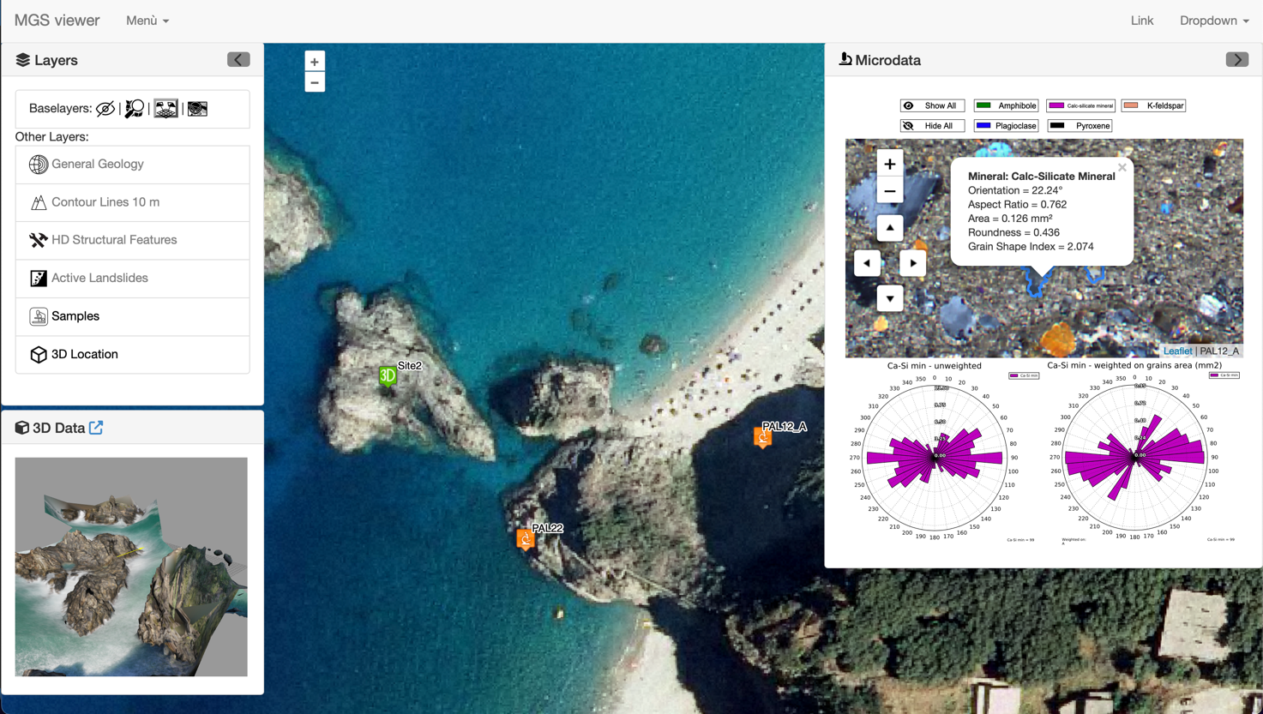

Figure Illustrative screenshot of the webGIS of the mylonitic Palmi Shear Zone taken as an example for simultaneous, multiscalar visualization of structural geological data useful for scientific, professional, and geo-tourist purposes.

In conclusion, the web-based system presented in this study represents a significant advancement in the realm of digital twins for territorial analysis, owing to its capability to manage and visualize multiscale data, ranging from the microscale to the geographic scale. This platform not only enhances data interoperability but also facilitates a comprehensive and integrated understanding of geological and geographical dynamics. These features make this web solution as a valuable tool for territorial planning, resource management, and the study of interactions across various spatial scales.

The risk of natural degradation of the study case area is medium to high, given its proximity to an area classified as a P4 hazard in the regional plane of the natural hazards (Triglia *et. al.*,2021) and because of the imminent risk of collapse of the cliff that dominates part of the beach in front of the stacks. Moreover, the area is subject in the summer months to a significant anthropic impact given by the crowded beach. Tourist flow should certainly be managed more consciously. For all the above reasons, it is thought that it is necessary for an appropriate plan of intervention of safety and conscious use, identifying with urgency and in consultation also with scientific institutions the specific areas to be safeguarded. The implementation of such a plan should include both structural and non-structural measures aimed at mitigating risks while preserving the natural and touristic value of the area. Structural interventions may involve cliff stabilization techniques, such as rock bolting or controlled drainage systems, to prevent sudden collapses and minimize hazards to beachgoers. Additionally, periodic geotechnical monitoring should be conducted to assess the evolution of erosion processes and provide early warnings in case of increased instability. On the other hand, non-structural measures should focus on raising awareness among visitors and local stakeholders about the fragility of the coastal environment. This can be achieved through educational campaigns, informative signage, and the implementation of controlled access paths to reduce human pressure on the most vulnerable areas. Furthermore, local authorities should consider the introduction of carrying capacity limits during peak tourist seasons to prevent excessive anthropic stress on the ecosystem.

In this context a crucial component for the integration of advanced decision-support instruments, such as a Multiscale Geo-Structural Information System, can provide a comprehensive and real-time effective communication of hazards, regulations, and reasons that led to the decisions in a Smart City Development approach (Wei *et.al.*, 2024; Miles et al., 2024).

# References

Acevedo Zamora, M. A., Schrank, C. E., & Kamber, B. S. (2024). Using the traditional microscope for mineral grain orientation determination: A prototype image analysis pipeline for optic‐axis mapping (POAM). *Journal of Microscopy*, *295*(2), 147–176.<https://doi.org/10.1111/jmi.13284>

Arnaud, R., & Barnes, M. C. (2006). COLLADA: sailing the gulf of 3D digital content creation. CRC Press.

Azmi, N. A., Shafri, H. Z. M., Abidin, F. A. Z., Shaharum, N. S. N., & Al-Habshi, M. M. A. (2022). Development of Web-GIS using open source geospatial technologies for Krau Wildlife Reserve. *IOP Conference Series: Earth and Environmental Science*, *1064*(1), 012016.<https://doi.org/10.1088/1755-1315/1064/1/012016>

Balla, D. and Gede, M. (2024). Beautiful thematic maps in Leaflet with automatic data classification, *Int. Arch. Photogramm. Remote Sens. Spatial Inf. Sci., XLVIII-4/W12-2024*, 3–10, <https://doi.org/10.5194/isprs-archives-XLVIII-4-W12-2024-3-2024>

Bachri, S., Sumarmi, Irawan, L. Y., Utaya, S., Wirawan, R., Nurdiansyah, F. D., Nurjanah, A. E., Tyas, L. W. N., Adillah, A. A., & Setia, D. (2022). FOSS (Free Open Source Software) Integration to Implement Web-GIS-Based Information System of Kelud Volcano. *IOP Conference Series: Earth and Environmental Science*, *1066*(1), 012010.<https://doi.org/10.1088/1755-1315/1066/1/012010>

Baumann, P., Misev, D., Merticariu, V., & Huu, B. P. (2021). Array databases: Concepts, standards, implementations. *Journal of Big Data*, *8*(1), 28.<https://doi.org/10.1186/s40537-020-00399-2>

Burggraf, D. (2015). OGC KML 2.3, Version 1.0. Wayland, MA, Open Geospatial Consortium, 266pp. (OGC 12-007r2). <https://doi.org/10.25607/obp-598>

Cheng, D. (2024). Research on HTML5 Responsive Web Front-end Development Based on Bootstrap Framework. 2024 7th International Conference on Computer Information Science and Application Technology (CISAT), 711–718. <https://doi.org/10.1109/CISAT62382.2024.10695228>

Cirrincione, R., Fazio, E., Ortolano, G., Pezzino, A., & Punturo, R. (2012). Fault-related rocks: deciphering the structural–metamorphic evolution of an accretionary wedge in a collisional belt, NE Sicily. *International Geology Review, 54(8), 940-956.* <https://doi.org/10.1080/00206814.2011.623022>

Cirrincione, R., Fazio, E., Fiannacca, P., Ortolano, G., Pezzino, A. & Punturo, R. (2015). The Calabria-Peloritani Orogen, a composite terrane in Central Mediterranean; its overall architecture and geodynamic significance for a pre-Alpine scenario around the Tethyan basin. *Periodico di Mineralogia, 84(3B), 701-49*. <https://doi.org/10.2451/2015pm0446>

Danchilla, B. (2012). Three.js Framework. In: *Beginning WebGL for HTML5 (pp-173-203)*. Apress, Berkeley, CA. <https://doi.org/10.1007/978-1-4302-3997-0_7>

Duarte, L., Queirós, C., & Teodoro, A. C. (2021). Comparative analysis of QGIS plugins for Web Maps creation. *La Granja*, *34*(2), 8–26.<https://doi.org/10.17163/lgr.n34.2021.01>

Elrom, E. (2016). CSS, Bootstrap, & Responsive Design. In: Pro MEAN Stack Development. Apress, Berkeley, CA. <https://doi.org/10.1007/978-1-4842-2044-3_6>

Fazio, E., Ortolano, G., Visalli, R., Cirrincione, R., Fiannacca, P., Kern, H., Mengel, K., Pezzino, A., & Punturo, R. (2018a). Strain rates of the syn-tectonic Symvolon pluton (Southern Rhodope Core Complex, Greece): an integrated approach combining quartz paleopiezometry, flow laws and PT pseudosections. *Italian Journal of Geosciences, 137(2), 219-237*. <https://doi.org/10.3301/IJG.2018.10>

Fazio, E., Ortolano, G., Visalli, R., Alsop, I., Cirrincione, R., & Pezzino, A. (2018b). Strain localization and sheath fold development during progressive deformation in a ductile shear zone: A case study of macro-to micro-scale structures from the Aspromonte Massif, Calabria. Italian Journal of Geosciences, 137(2), 208-218. <https://doi.org/10.3301/IJG.2018.09>

Fazio, E., Ortolano, G., Alsop, G. I., D’Agostino, A., Visalli, R., Luzin, V., Salvemini, F., & Cirrincione, R. (2024a). Enhanced structural analysis through a hybrid analogue-digital mapping approach: Integrating field and UAV survey with microtomography to characterize metamorphic rocks. *Journal of Structural Geology*, *187*. Scopus. <https://doi.org/10.1016/j.jsg.2024.105213>

Fazio, E., Ortolano, G., Monaco, C., & Alsop, G. I. (2024b). A journey through ductile to brittle deformation of rocks: How traditional geoscience benefits from innovations–An introduction. Journal of Structural Geology.

Foerster, T., Stoter, J., & van Oosterom, P. (2012). On-demand base maps on the web generalized according to user profiles. *International Journal of Geographical Information Science*, *26*(1), 99-121. <https://doi.org/10.1080/13658816.2011.574292>

Gede, M. (2023). Automatic Labels in Leaflet, *Adv. Cartogr. GIScience Int. Cartogr. Assoc., 4, 8,* <https://doi.org/10.5194/ica-adv-4-8-2023>

González Canché, M. S. (2023). Data formats, coordinate reference systems, and differential privacy frameworks. In Spatial socio-econometric modeling (SSEM): A low-code toolkit for spatial data science and interactive visualizations using R (pp. 55–94). Springer International Publishing. <https://doi.org/10.1007/978-3-031-24857-3_3>

Han, Y. (2015). Cloud storage for digital preservation: optimal uses of Amazon S3 and Glacier. *Library Hi Tech*, *33*(2), 261-271. <https://doi.org/10.1108/lht-12-2014-0118>

Heilbronner, R. (2000). Automatic grain boundary detection and grain size analysis using polarization micrographs or orientation images. *Journal of Structural Geology*, *22*(7), 969–981.<https://doi.org/10.1016/S0191-8141(00)00014-6>

Hossain, M. (2014). *CORS in action: Creating and consuming cross-origin apis*. Simon and Schuster, 2014, ISBN: 1638353255

Kirk, A. (2012). Data Visualization: A Successful Design Process. *Packt Publishing Ltd., ISBN: 1-84969-346-3*

Krygier, J., & Wood, D. (2016). *Making maps: a visual guide to map design for GIS*. Guilford Publications. ISBN: 9781462556069

Kumari, P., & Kumari, M. (2023). Exploring Static Website Development A Fundamental Analysis of Design and Functionality. *International Journal of Communication Systems and Network Technologies*, *Vol 11*(No. 2) <http://www.ijcsnt.info/papers/IJCSNT_11_2_08.pdf>

Li, Y., Onasch, C. M., & Guo, Y. (2008). GIS-based detection of grain boundaries. *Journal of Structural Geology*, *30*(4), 431–443.<https://doi.org/10.1016/j.jsg.2007.12.007>

Li, N., & Zhang, B. (2021). The research on single page application front-end development based on Vue. In *Journal of Physics: Conference Series* (Vol. 1883, No. 1, p. 012030). IOP Publishing. <https://doi.org/10.1088/1742-6596/1883/1/012030>

Maestri, L. (2017). *Visualization of computer-generated 3D cities using GIS data* [Application/pdf]. 66 pages.<https://doi.org/10.34726/HSS.2017.29835>

Mamtani, M.A. (2025). The Future of Structural Geology in the 21st Century – Moving from Mesoscale to Nanoscale Observations in Tectonically Deformed Rocks. *Journal of the Geological Society of India 101(1): p.10-23*. <https://doi.org/10.17491/jgsi/2025/174056>

Markieta, M., & Rinner, C. (2014). Using Distributed Map Overlay and Layer Opacity for Visual Multi-Criteria Analysis. *GEOMATICA*, *68*(2), 95–105.<https://doi.org/10.5623/cig2014-202>

Mason, P. (2020). JavaScript Libraries. In: SAS Stored Processes. Apress, Berkeley, CA. <https://doi.org/10.1007/978-1-4842-5925-2_5>

McInerney, D., & Kempeneers, P. (2015). Image Overviews, Tiling and Pyramids. In D. McInerney & P. Kempeneers, *Open Source Geospatial Tools* (pp. 85–97). Springer International Publishing.<https://doi.org/10.1007/978-3-319-01824-9_7>

Melsom, J. (2020). Multi-scalar geo-landscape models: Interfacing geological models with landscape surface data. *Journal of Digital Landscape Architecture*. <https://doi.org/10.14627/537690007>

Mete, M. O., & Yomralioglu, T. (2021). Implementation of serverless cloud GIS platform for land valuation. International Journal of Digital Earth, 14(7), 836–850. <https://doi.org/10.1080/17538947.2021.1889056>

Miles, V., Esau, I., & Pettersson, L. (2024). Using web GIS to promote stakeholder understanding of scientific results in sustainable urban development: A case study in Bergen, Norway. *Sustainable Development, 32(3), 2517–2529*. <https://doi.org/10.1002/sd.2787>

Naik, P. & Naik, G. (2024). Mastering Bootstrap, AJAX, and jQuery for Elevating Web Experiences with Advanced Development Techniques. ISBN: 978-93-6087-864-1

Norman, D. A. (2013) The Design of everyday things, Basic Group, New York, ISBN 978-0-465-00394-5

Ortolano, G., Fazio, E., Visalli, R., Alsop, G. I., Pagano, M., & Cirrincione, R. (2020). Quantitative microstructural analysis of mylonites formed during Alpine tectonics in the western Mediterranean realm. Journal of Structural Geology, 131, 103956. <https://doi.org/10.1016/j.jsg.2019.103956>

Ortolano, G., Cirrincione, R., Pezzino, A., & Puliatti, G. (2013). Geo-Petro-Structural study of the Palmi shear zone: Kinematic and rheological implications. *Rendiconti Online della Società Geologica Italiana, 29, 126-129*.

Ortolano, G., Zappalà, L., & Mazzoleni, P. (2014). X-Ray Map Analyser: A new ArcGIS® based tool for the quantitative statistical data handling of X-ray maps (Geo-and material-science applications). Computers & Geosciences, 72, 49-64. <https://doi.org/10.1016/j.cageo.2014.07.006>

Ortolano, G., Visalli, R., Godard, G., & Cirrincione, R. (2018). Quantitative X-ray Map Analyser (Q-XRMA): A new GIS-based statistical approach to Mineral Image Analysis. Computers & Geosciences, 115, 56-65. <https://doi.org/10.1016/j.cageo.2018.03.001>

Ortolano, G., Fazio, E., Visalli, R., Alsop, G. I., Pagano, M., & Cirrincione, R. (2020). Quantitative microstructural analysis of mylonites formed during Alpine tectonics in the western Mediterranean realm. Journal of Structural Geology, 131, 103956. <https://doi.org/10.1016/j.jsg.2019.103956>

Ortolano, G., D’Agostino, A., Pagano, M., Visalli, R., Zucali, M., Fazio, E., Alsop, I., & Cirrincione, R. (2021). ArcStereoNet: A new ArcGIS® toolbox for projection and analysis of meso-and micro-structural data. *ISPRS International Journal of Geo-Information*, *10*(2), 50. <https://doi.org/10.3390/ijgi10020050>

Ortolano, G., Pagano, M., Visalli, R., Angì, G., D’Agostino, A., Muto, F., Tripodi, V., Critelli, S., & Cirrincione, R. (2022). Geology and structure of the Serre Massif upper crust: a look in to the late-Variscan strike–slip kinematics of the Southern European Variscan chain. *Journal of Maps, 18(2), 314-330.* <https://doi.org/10.1080/17445647.2022.2057876>

Passchier, C. W., & Trouw, R. A. (2005). Microtectonics. *Springer Science & Business Media*. ISBN: 978-3-540-29359-0.

Preda, M., Arsov, I., & Moran, F. (2010). COLLADA + MPEG-4 OR X3D + MPEG-4. *IEEE Vehicular Technology Magazine*, *5*(1), 39–47.<https://doi.org/10.1109/MVT.2009.935544>

Prosser, G., Caggianelli, A., Rottura, A., & Del Moro, A. (2003). Strain localisation driven by marble layers: The Palmi shear zone (Calabria-Peloritani terrane, Southern Italy). *GeoActa, 2, 155-166.*

Punturo, R., Matmani, M.A., Fazio, E., Occhipinti, R., Renjith, A.R. & Cirrincione, R. (2017). Seismic and magnetic susceptibility anisotropy of middle-lower continental crust: Insights for their potential relationship from a study of intrusive rocks from the Serre Massif (Calabria, southern Italy). *Tectonophysics, 712–713, (542-556)*, [https://doi.org/10.1016/j.tecto.2017.06. 020](https://doi.org/10.1016/j.tecto.2017.06.%20020).

Rahman, A. D. M., & Cahyono, A. B. (2023). Analysis Of 3-D Building Modeling Using Photogrammetric Software: Agisoft Metashape And Micmac. *In IOP Conference Series: Earth and Environmental Science (Vol. 1276, No. 1, p. 012044). IOP Publishing*. <https://doi.org/10.1088/1755-1315/1276/1/012044>

Romero-Organvidez, D., Horcas, J.-M., Galindo, J. A., & Benavides, D. (2024). Data visualization guidance using a software product line approach. *Journal of Systems and Software*, *213*, 112029.<https://doi.org/10.1016/j.jss.2024.112029>

Russo D., Fiannacca P., Fazio E., Cirrincione R., & Mamtani M.A. (2023). From floor to roof of a batholith: geology and petrography of the north-eastern Serre Batholith (Calabria, southern Italy). *Journal of Maps, 19 (1)*. <https://doi.org/10.1080/17445647.2022.2149358>

Simon, M. (2023). Manipulating HTML Elements. In: JavaScript for Web Developers. Apress, Berkeley, CA. <https://doi.org/10.1007/978-1-4842-9774-2_3>

Steiniger, S., & Hunter, A. J. S. (2013). The 2012 free and open source GIS software map – A guide to facilitate research, development, and adoption. *Computers, Environment and Urban Systems*, *39*, 136–150.<https://doi.org/10.1016/j.compenvurbsys.2012.10.003>

Snyder, J. P. (1997). Flattening the earth: two thousand years of map projections. University of Chicago Press.

Tarquini, S., & Favalli, M. (2010). A microscopic information system (MIS) for petrographic analysis. *Computers & Geosciences*, *36*(5), 665–674.<https://doi.org/10.1016/j.cageo.2009.09.017>

Tarquini, S., & Armienti, P. (2011). Quick determination of crystal size distributions of rocks by means of a color scanner. *Image Analysis & Stereology*, *22*(1), 27.<https://doi.org/10.5566/ias.v22.p27-34>

Tavani S., Corradetti A., Rizzo R.E., & Seers T.D. (2024). Best practices towards the digitization of 3D traces from virtual outcrop models. *Journal of Structural Geology, 186, art. no. 105222* <https://doi.org/10.1016/j.jsg.2024.105222>

Teodorovici, V. G. (2013). jQuery, jQuery UI and jQuery Mobile: Recipes and examples by Adriaan de Jonge and Phil Dutson. ACM SIGSOFT Software Engineering Notes, 38(5), 68–69. <https://doi.org/10.1145/2507288.2507294>

Thiele, S.T., Grose, L., Samsu, A., Micklethwaite, S., Vollgger, S.A. & Cruden, A.R. (2017). Rapid, semi-automatic fracture and contact mapping for point clouds, images and geophysical data. *Solid Earth 8, 1241–1253*. <https://doi.org/10.5194/se-8-1241-2017>

Trigila A., Iadanza C., Lastoria B., Bussettini M., Barbano A. (2021) Dissesto idrogeologico in Italia: pericolosità e indicatori di rischio - Edizione 2021. ISPRA, Rapporti 356/2021. ISBN: 978-88-448-1085-6

Vakali, A., & Pallis, G. (2003). Content delivery networks: Status and trends. *IEEE Internet Computing*, *7*(6), 68–74.<https://doi.org/10.1109/MIC.2003.1250586>

Vasuki, Y., Holden, E.-J., Kovesi, P., & Micklethwaite, S. (2014). Semi-automatic mapping of geological Structures using UAV-based photogrammetric data: An image analysis approach. *Computers & Geosciences 69, 22–32*. <https://doi.org/10.1016/j.cageo.2014.04.012>

Viglino, JM. (2024). *ol-ext*: *Extensions for OpenLayers* [Repository]. Ol-Ext: Extensions for OpenLayers (Ol).<https://viglino.github.io/ol-ext/>

Visalli, R., Ortolano, G., Godard, G., & Cirrincione, R. (2021). Micro-Fabric Analyzer (MFA): A new semiautomated ArcGIS-based edge detector for quantitative microstructural analysis of rock thin-sections. *ISPRS International Journal of Geo-Information*, *10*(2), 51. <https://doi.org/10.3390/ijgi10020051>

Visser, M, Van Der Mark, W., Hoving, M. (2019), Designing effective websites, Routledge, ISBN: 9781003021674

Xypolias, P. (2010). Vorticity analysis in shear zones: A review of methods and applications. Journal of Structural Geology 32, 2072–2092. <https://doi.org/10.1016/j.jsg.2010.08.009>

Walny, J., Frisson, C., West, M., Kosminsky, D., Knudsen, S., Carpendale, S., & Willett, W. (2020). Data Changes Everything: Challenges and Opportunities in Data Visualization Design Handoff. *IEEE Transactions on Visualization and Computer Graphics*, *26*(1), 12–22.<https://doi.org/10.1109/TVCG.2019.2934538>

Wei, Y., Yuan, H., & Li, H. (2024). Exploring the Contribution of Advanced Systems in Smart City Development for the Regeneration of Urban Industrial Heritage. *Buildings, 14(3), 583*. <https://doi.org/10.3390/buildings14030583>

Wise, D. U., Dunn, D. E., Engelder, J. T., Geiser, P. A., Hatcher, R. D., Kish, S. A., Odom, A. L., & Schamel, S. (1984). Fault-related rocks: Suggestions for terminology. Geology, 12(7), 391-394. <https://doi.org/10.1130/0091-7613(1984)12%3C391:FRSFT%3E2.0.CO;2>

Wohlmann, J. (2024). Expanding the field of view: A simple approach for interactive visualisation of electron microscopy data. *Journal of Cell Science*, jcs.262198.<https://doi.org/10.1242/jcs.262198>

# Tables

Table List of functions used in "LIS\_functions.py" library

| Function name | Input | Output | Description |
| --- | --- | --- | --- |
| upload\_files\_widgets | N.A. | User Interface with loader for: Shapefile\_selector, Jpgfile\_selector, projectname | Create a User Interface in a Jupyter Notebook for input files loading |
| save\_to\_temp\_dir | Shapefile\_selector,Jpgfile\_selector, projectname | files\_path | Save to a temporary directory the files |
| run\_gdal2tiles | files\_path['Raster\_path']  projectname | Folder with tiles and a basic html map viewer  openlayers.html | Create tiles from a raster file and a basic html file viewer |
| convert\_shp\_to\_geojson | files\_path['Shp\_file\_path']  output\_file\_path | GeoJSon file | Convert SHP to GeoJSON by an ogr2ogr subprocess |
| add\_geojson\_overlay\_to\_gdal2tiles\_html\_output | openlayers.html  Projectname  GeoJson file | index.html | Add GeoJSON overlay to raster feature, using OpenLayers JS and CSS |
| add\_popup\_feature\_to\_gdal2tiles\_html\_output | index.html  GeoJson file | index2.html | Add PopUp feature capable to visualize grain data, using ol-ext JS and CSS |
| add\_legend\_and\_rosediagrams | index2.html  Rosediagram files | index3.html | Add legend icons and JS capable to update rose diagrams after user click on grain polygons |

Table Required fields table of mineral-data Shapefile used for thin section petrographical data visualization

|  |  |  |  |
| --- | --- | --- | --- |
| Field name | Type | Example value | Description |
| Mineral | str | Pl | Coded name of mineral |
| O | float | 90.0 | Degree of orientation |
| Asr | float | 0.39438 | Aspect Ratio |
| A | float | 0.12928 | Area in micrometers |
| R | float | 0.58411 | Roundness |
| GSI | float | 1.87833 | Grain Shape Index |

Table The sorted list of functions and variables used in the process of creation of a 3D geological model web-viewer using the KMZViewer\_function.py library

|  |  |  |
| --- | --- | --- |
| **Item** | **Variable or function** | **Description** |
| #1 | KMZ\_HTMLHEAD | Html header, title of page and simple meta tag |
| #2 | KMZ\_IMPORTLIBS | Script for import Three.JS from a CDN server |
| #3 | KMZ\_THREEJS\_ADDONS\_FILES\_ADD\_TO\_PROJECT() | Function to create folder and file for packaging |
| #4 | KMZ\_OPENINGSCRIPT | The html row of script that open customized code for viewer |
| #5 | KMZ\_LOADINGIMAGE() | Function to create Javascript code that load an GIFimage as a splash screen |
| #6 | KMZ\_THREEJS\_script() | Function to create JS code for loading an KMZ file |
| #7 | KMZ\_CLOSINGSCRIPT | String with HTML code for closing script tag |
| #8 | KMZ\_STYLE | Html code with CSS nested |
| #9 | KMZ\_HTMLFOOT | Html code with closing tag and footer |

# Figure legends

* **Figure 1** - Static webpage approach in webGIS environment
* **Figure 2** - Tools and process diagram for packaging static webpages for Multiscale Geo-structural information System (MGS)
* **Figure 3** - Petrographical data web-viewer features and simplified creation process diagram
* **Figure 4** – Detailed process for production of a Petrographic data viewer using LIS\_function.py tools
* **Figure 5** - The web view of result of Step #2 of Petrographic data viewer creation process using LIS\_functions.py tools
* **Figure 6** - The web view result of Step #3 of Petrographic data viewer creation process using LIS\_functions.py tools, vector grain boundary overlay in the thin section raster data
* **Figure 7** - Output web view after the final "*add\_legend\_and\_rosediagrams*" procedure in LIS\_functions.py library sequence. Users can access specific mineral grain properties of a single grain (polygon appears with an highlighted boundary) and global statistics. A visual representation of mineral grains orientation is provided through rose diagram charts, both unweighted (concentric circles indicates cumulative number of grains) and weighted on grains area (concentric circles indicates cumulative area of grains in mm2).
* **Figure 8** - The 3D geological models web viewer features and simplified creation process
* **Figure 9** - A Jupyter-notebook interface with the only two steps required to create a web-viewer static page of a KMZ file using the *KMZViewer\_function.py*
* **Figure 10** - Output web view of a 3D model using *KMZviewer\_functions.py*
* **Figure 11** - Geographical and maps data viewer features and creation process
* **Figure 12** - Global diagram for packaging a Multiscale Geo-structural information System (MGS) web viewer features and crafting process
* **Figure 13** - Geological location of the mylonitic rocks outcrop chosen as test site for the Web-GIS development. a) Geological sketch map of the basement rocks forming the Calabrian Peloritani Orogen; b) Geological map of the general study area and location of the detailed study area; c) panoramic view of the Ulvarella stacks with trace of the subvertical mylonitic foliation.
* **Figure 14** - Structural geological map of the detailed study area chosen as test site for the Web-GIS development.
* **Figure 15** - From Fazio *et al.* (2024a): a) Panoramic view of the most far Ulivarella Stack from the beach; b) Ultramylonitic layer developed at the expenses of the migmatitic paragneisses and of the metacarbonate rocks (upper dark layer); c) sheath fold in the upper limb of a metric fold (FAP2); d) vertical surface of outcrop with a dextrally-sheared sheath fold and several clasts displaying opposite shear sense; e) clast indicating top-to-the-ENE shear sense; f) interpretation of structures depicted in (e); the inset shows a stereoplot with location of a clockwise vorticity axis compatible with the clast at the center of the picture (after Fazio *et al.,* 2024a).
* **Figure 16** - Present-day distribution of the Alpine and Pre-Alpine Basement in western Mediterranean realm with CPO location and main Alpine strike-slip tectonic alignment (modified after Cirrincione *et al*., 2015).
* **Figure 17** - Geological structural maps of the a) Ulivarella Stack 1, and b) Ulivarella Stack 2, derived from the UAV surveys data produced in Fazio *et al.* (2024a)
* **Figure 18** - High resolution thin section scans: a,c,e) Plane-polarized Light; b.d.f) Crossed-polarized Light.
* **Figure 19** - (modified after Ortolano *et al*., 2020). Mineral phase classification with mineral grain size distribution outputs and distribution of the porphiroclast domains with their relative rose diagrams for: a) PAL11; b) PAL12a; and c) PAL22.

**Figure 20** - Illustrative screenshot of the webGIS of the mylonitic Palmi Shear Zone taken as an example for simultaneous, multiscalar visualization of structural geological data useful for scientific, professional, and geo-tourist purposes.